CompuCrete® Accounting
Order Entry & Ticketing
Quick Overview

ORDER MAINTENANCE screen
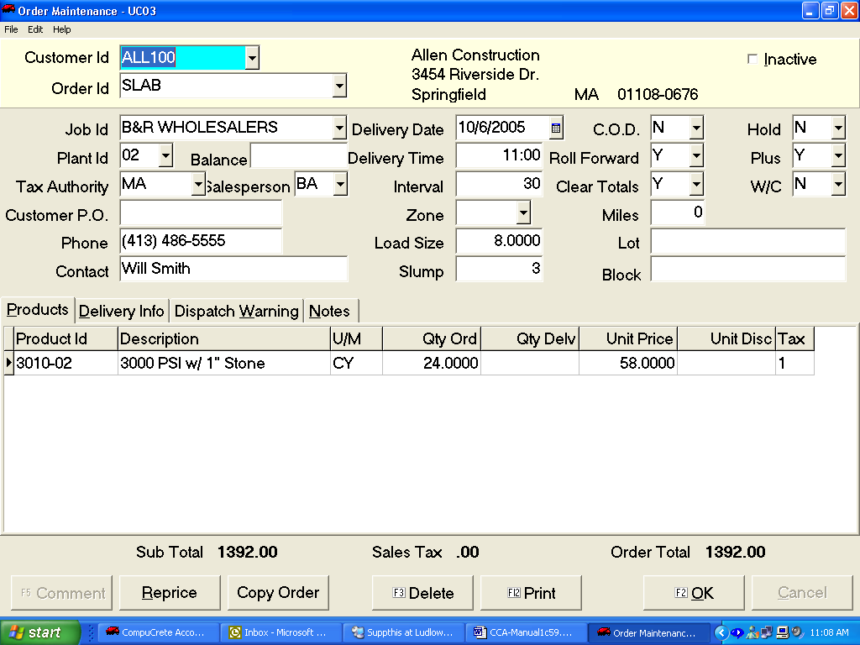

Order Entry fields
CUST ID – This is the ID code for the customer getting the order (Tip: Hit the F4 key to search by name if you don’t know the customers actual code)
ORD ID - This is the ID of the order sometimes used as a location of the JOB or as
a usage code… (i.e. SLAB) in the example, however the id can be used as you wish
JOB ID - This is typically the location of the job but you can use it for special
pricing purposes
PLANT ID - The plant the order is shipping out of
BALANCE - The total $ that have been shipped on the order so far (the system keeps
track of this after every load is shipped, no you need to edit this manually)
TAX AUTH - The tax code or % of tax typically defaulting in from the customer setup,
plant setup, or job setup. (most places are taxed based on where it is delivered and not
where it is shipped from)
SALESPERSON – This is the salesperson for this account (typically defaults in from
customer maintenance)
CUSTOMER PO – If there is a PO number associated with this order
PHONE - Phone # for the contact of this order
CONTACT - Contact for this order
DELIVERY DATE – Date the order is to ship
DELIVERY TIME – Time the first load is to ship (if you use the Intervals the system up-dates the time automatically after every load ships so you know when the next load is due)
INTERVAL - # of minutes between loads
ZONE - If there are zone charges setup depending on where the delivery location
is you need to use a Zone
LOAD SIZE - Default load size when printing a ticket
SLUMP - Concrete Slump, can print on ticket
COD - Is this cash on delivery order? Prices can then print on ticket
HOLD - Do you want to hold the order if not firm?
ROLL FWD - Do you want this order to roll to tomorrow upon Beginning of Day?
PLUS - Is this a plus order?
CLR TOTALS – If rolling order forward to next day, should the system clear the amounts that have been shipped the next day and treat like a new order?
W/C - Will Call order, waiting for customer to call and firm it up
MILES - Round trip miles for load
LOT - Lot # if subdivision
BLOCK - Block #

ORDER STACK screen
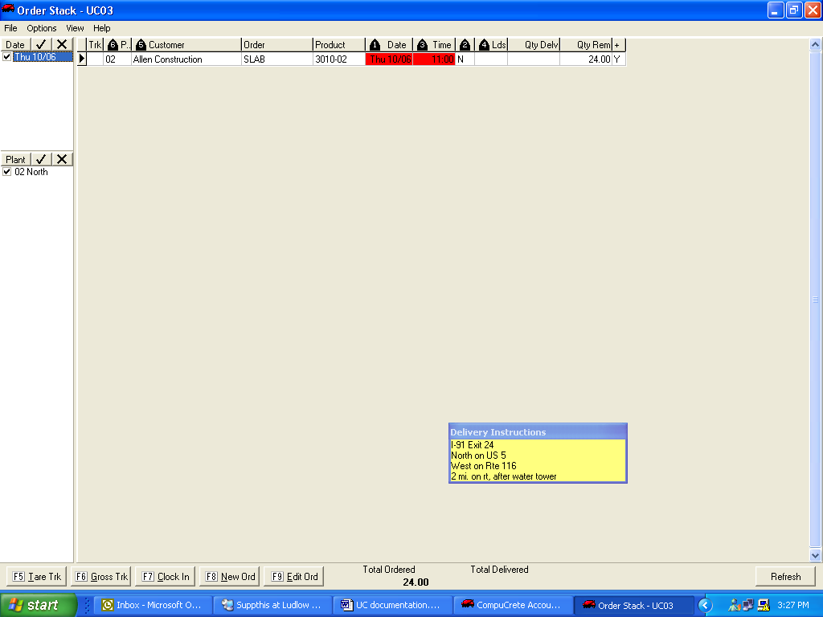

TRK - Trucks on job w/c - Will Call Order Y or N
PLT - Shipping plant LDS - Quantity ticketed so far on this order
CUSTOMER - Customer’s name QTY DELV - Yards or Quantity shipped
ORDER - Order # or ID QTY REM - Qty remaining to complete Order
PRODUCT - Main product on order + - Plus order or not
DATE - Delivery Date
TIME - This is the next load time. It is updated every time you ship a load by the intervals set up on the order
Button Descriptions
TARE TRK - (F5) For Agg Trucks can re-weigh a trucks Tare to update the Truck info
GROSS TRK - (F6) Can Re-Gross a truck, but usually done when printing the ticket
CLOCK IN - (F7) Can Clock a Truck in yard to take him off the job when he returns
NEW ORD - (F8) Take brand new order for today or future days
EDIT ORD - (F9) Can edit an existing Order or Delete if desired
REFRESH - Refresh or re-update screen

Beginning of Day screen
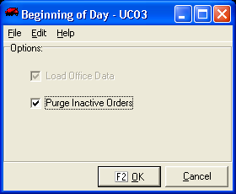

Function - To Purge old orders and Roll any Orders forward to the current day

Ticket Printing screen
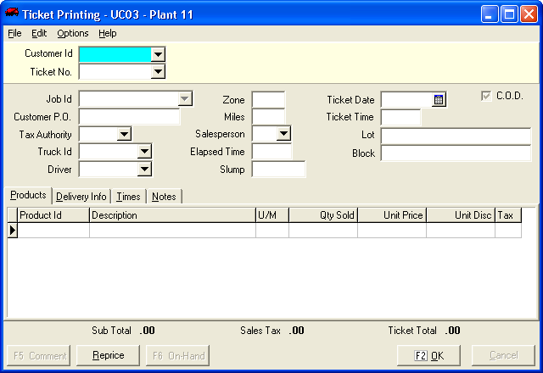

Function - Printing Tickets on the fly without an order
Weigh Truck screen
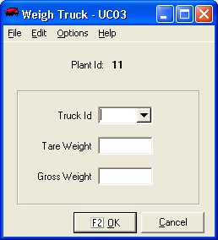

Function - To Re-Tare a truck

On-Hand Inquiry screen
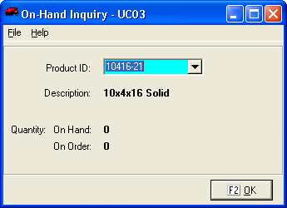

Function - Check on an in-stock item

Order Maintenance screen
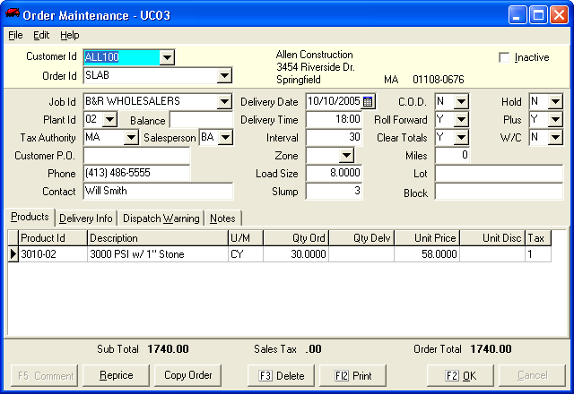

Function - To Add/Change/Delete an order

Order List screen
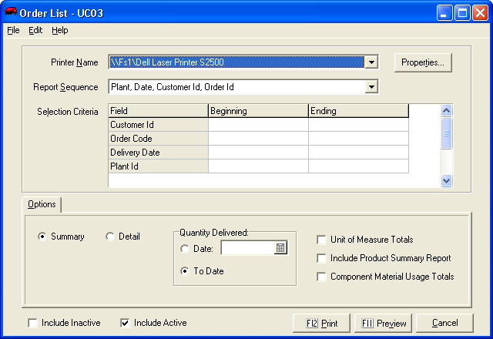

Function - To get a report or Order List
Void Ticket screen
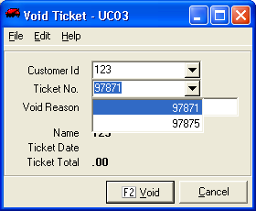

Function - To void out a ticket

Re-Print ticket screen
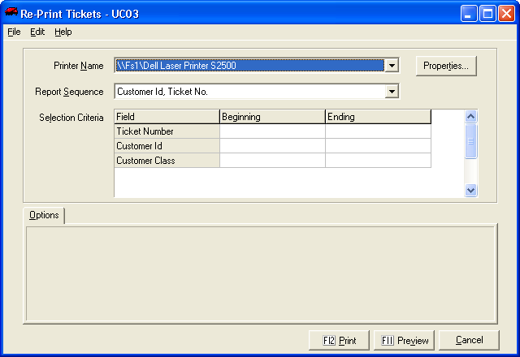

Function - To re-print out a ticket

End of Day screen
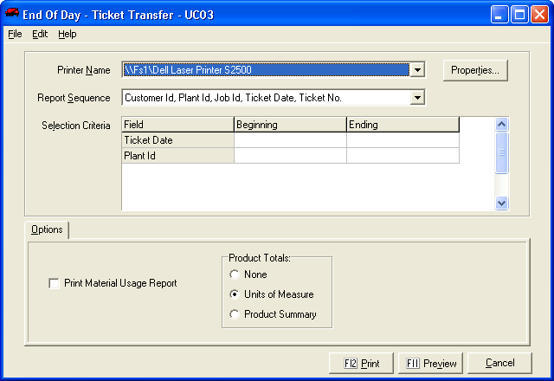

Function - To run a report of the daily ticketing activity and close out all tickets so that accounting can bill them…

