

.
Industry Specific Accounting

for Concrete and Aggregate Producers

Dispatch

User Manual and Reference

Hansco Information Technologies, Inc.

Hansco Information Technologies, Inc.

Keystone Dispatch User Manual and Reference
Version 2.0.20.0 9/30/2007

2400 Corporate Exchange Drive, Columbus, Ohio 42325
Phone: 614-310-0060 Fax: 614-310-0066

185 West Avenue, Suite 304 Ludlow, Massachusetts 01056
Phone: 413-547-8991 800-548-9754 Fax: 413-547-8505

Windows is a registered trademark of Microsoft Corp.
Interbase is a registered trademark of Borland/Inprise Corp.
All software, the Keystone name and related documents are the proprietary trade secrets and property of GivenHansco, Inc., Worthington, OH, USA. All rights reserved. GivenHansco is not responsible for misprints in this document. No Warranty is implied in the use of the software.
Keystone is a registered trademark of GivenHansco, Inc.

Printed in U.S.A. Copyright © 2007

Keystone® Dispatch Manual
and Reference

Contents

Keystone® Dispatch Manual and Reference 1
Contents 1
SYSTEM OVERVIEW 7
Introduction 7
Key Concepts 8
Foreword 8
Adding & Editing Data 8
Batch Control Interface 8
GPS (Global Position Systems) / Truck Tracking (Messaging) 8
Orders & Order Entry 9
Projected Loads 9
Truck Tracking 9
Data Flow 10
Customer Data 10
Pricing Data 10
Order Entry 10
Delivery Tickets 10
Office Data 10
System Startup 11
Prior to installing 11
System setup 11
MENU OPTIONS 12
Menu Navigation – Dispatch 12
Menu Overview 12
Beginning of Day 13
Schedule Screen 14
Selecting Data 15
Selecting Dates 15
Selecting Plants 15
Selecting fields 16
Changing field location 16
Changing order sequence 16
Order Maintenance 17
Customer Id 18
Order Id 18
Job Id 20
Additional Data Entry Fields 20
Plant Id 20
P.O. 20
Delv. Date 20
Time 20
Zone 20
Zone Time 20
Usage Type 20
Unload Time 20
Load Size 20
Spacing 20
Slump 20
Truck Type 20
Order Status 20
C.O.D. 21
Plus 21
W/C 21
Roll Forward 21
Print Prices 21
Print Weights 21
Phone 21
Contact 21
Lot 21
Block 21
Tax Auth 21
Slspn 21
Balance 21
Information Tabs 22
Products Tab 22
Product Id 22
Description 22
U/M 22
Qty Ord 22
Qty Delv 22
Unit Price 22
Unit Disc 22
Tax 22
Delivery Info Tab 23
Dispatch Warning Tab 23
Times Tab 23
Notes Tab 23
History Tab 23
Events Tab 24
Loads Tab 24
Warnings Tab 24
Control Buttons / Function Keys 24
F5 Comment 24
Reprice 24
Copy Order 25
F3 Delete 25
F12 Print 25
Recalc 25
F2 OK 25
Cancel 25
Ticket Printing 26
Truck Demand Graph 27
Plant Selection 28
Graph Settings 28
Diagnostic Data 29
Timeslot Order detail 30
Outbound Loads 30
On Job Loads 30
Concrete Calculator 31
Calculating volume 32
Job Totaling 32
Other Shapes 33
End of Day 34
Report Sequence Options 35
Additional Report Options 35
Material Usage Report 35
Show 8 Inch Equivalence 35
Product Totals 35
Menu Navigation – File Maintenance 36
Menu Overview 36
Ticket Maintenance 37
Truck File Maintenance 38
Truck Maintenance Data Entry Fields 39
Truck Id 39
Tare Weight 39
Last Tared 39
Legal Max 39
Home Plant 39
Truck Class 39
Customer Id 39
Owner Id 39
Default Driver 39
Inc. on Reports 39
Internal 39
In Service 39
VIN No. 39
Make 39
Model 39
Year 39
Exp. Date 39
Driver File Maintenance 40
Plant File Maintenance 41
Plant Type Setup 42
Ticketing Setup 42
Dispatch Setup 43
Device Setup 44
Event Type Maintenance 45
Usage Class Maintenance 46
Zone Maintenance 47
Time-based zones 47
Delivery-based zones 47
Map-based zones 47
Menu Navigation – File Lists 48
Menu Overview 48
Orders List 49
Report Sequence 49
Summary / Detail 49
Unit of Measure Totals 49
Product Summary Usage 49
Component Material Usage 49
Truck List 51
Report Sequence 51
Driver List 52
Report Sequence 52
Plant List 53
Report Sequence 53
Zone List 55
Report Sequence 55
Menu Navigation – Reports 56
Menu Overview 56
Detailed Yardage Report 57
Report Sequence 57
Load Schedule Report 58
Report Sequence 58
Plant Productivity Report 59
Driver Time/Yardage Analysis 60
Report Sequence 60
Order Time/Yardage Analysis 61
Report Sequence 61
Plant Time/Yardage Analysis 62
Report Sequence 62
Blank Time Fields Report 63
Report Sequence 63
Late Times Report 64
Report Sequence 64
Ticket Time Analysis 65
Report Sequence 65
Options Tab 65
Selecting tickets 65
Selecting Time fields to analyze 66
Time Variance Calculation 66
Late Tolerance 66
Show Target Times 67
Ticket Sources Tab 67
Order Audit Trail 69
Report Sequence 69
Menu Navigation – Utilities 70
Menu Overview 70
Void Ticket 71
Re-Print Ticket 72
Re-transfer Dispatch Tickets 73
Appendix A - Delivery Zones 74
Zone Methods 74
• Time-Based times 74
• Delivery-based zones 74
• Map-based zones 75

SYSTEM OVERVIEW

Introduction
The Keystone Dispatch System is the truck dispatching module within the Keystone software suite. It handles all aspects of Dispatch, from order entry and truck tracking (with optional GPS interface), through reporting and ultimately billing via the Accounts Receivable module.
The Dispatch module features very powerful reporting capabilities, allowing analysis of driver, driver and customer efficiency and overall plant production.
This manual contains a “Key Concepts” section. Understanding these concepts is vitally important to deriving the best use of Keystone Dispatch. Please read this section thoroughly, and if a point is not very clear, please contact your GivenHansco Representative for further clarification.

Key Concepts

Foreword
Please read the following section carefully! The entire Dispatch system is based on these key concepts. Attempting to use Dispatch without a complete understanding of them increases the likelihood of inaccurate data.

Adding & Editing Data
To reduce the number of screens and menu options, most Keystone screens are used for both adding new entries as well as editing existing ones.
In general, information is added less frequently than it is reviewed and edited. Keystone therefore assumes that when data entry begins, the user is looking to retrieve data rather than add something new. If a user is attempting to add data, the user must either click on the + button, or hit the Insert key.

Batch Control Interface
Keystone Dispatch supports a variety of batch controls. Keystone Batch is our preferred batch control as it offers the best integration and allows support staff to run diagnostics on both systems when necessary. A wide variety of other batch controls are supported as well.
The information shared between Keystone Dispatch and your batch control can vary depending on the batch control.
In most cases, your batch control’s data must be set up to match Keystone Dispatch’s in such areas as customers, products (with mix designs), trucks, tax authorities, etc.
If you plan to change batch controls after your installation, you must contact GivenHansco support at least two week’s in advance to avoid disruptions in your production.

GPS (Global Position Systems) / Truck Tracking (Messaging)
Keystone Dispatch can be interfaced to many GPS or Truck Tracking systems. Keystone GPS is the preferred system, as it allows support staff to run diagnostics on both systems when necessary.
Without a GPS / Truck Tracking system, the dispatcher must manually move each truck through all phases of a pour.

Orders & Order Entry
Orders must be entered completely and accurately in order for Keystone Dispatch to correctly project the demands of the order. Order numbers are assigned at the time of entry.
Any changes made to an order where loads have already been shipped will only impact future loads. Information on loads that have already been shipped will remain unchanged unless the ticket is voided.
Once an order has begun shipping, it cannot be deleted.

Projected Loads
In order to build the schedule correctly, Keystone Dispatch must project the loads for each order. For example, an order for 100 CY with 10 CY per load will require 10 loads. After calculating the times based on the values provided by the user, Keystone Dispatch will have the estimates start and return time for each load and update the schedule accordingly.
Changes in load size or total yardage can impact these projected loads. For example, if the customer calls and requests an additional 30 cubic yards, an additional 3 loads will be required. Similarly, if with 20 yards remaining, the customer requests 5 CY loads, the two projected remaining loads would need to become four projected loads.
Any time there is a change to the Projected Loads, Keystone Dispatch will warn the Dispatcher and offer choices on ways to proceed.

Truck Tracking
Keystone Dispatch tracks trucks’ status through their operation (loading, leaving plant, etc.) as well as their on-time progress through each stage. Dispatchers must manually move trucks through each stage unless an interface to a GPS or truck-tracking is purchased.

Data Flow

Customer Data
Customer & billing data is maintained from the Accounts Receivable module. This relieves the dispatcher of needing to maintain customer information such as address, credit status and other data not immediately critical to the functions of dispatch.

Pricing Data
Pricing data is similarly maintained using the Accounts Receivable module, though at the customer’s option, can be turned over to the dispatcher or dispatch manager. These types of issues should be discussed with your GivenHansco Installation Coordinator.

Order Entry
All orders are entered via Order Entry. Based on the information provided, Keystone Dispatch projects the plant and truck requirements as well as organizing the schedule to meet the needs of your customers and builds the schedule screen to keep dispatchers up to date on the day’s demand.

Delivery Tickets
As loads are dispatched, each load’s delivery ticket is stored for later transfer to the Keystone Accounts Receivable system. This eliminates the need for redundant data entry by office staff.
Delivery tickets are retained until invoiced by the Accounts Receivable system, when their data is stored in a sales history file. This stored data is stored indefinitely, allowing reporting for many years in the future.

Office Data
After processing the delivery tickets, the Accounts Receivable data is updated and used by Dispatch to assure compliance with credit limits, pricing, etc.

System Startup
Prior to installing | In order to get your Keystone Dispatch system started there are some special steps to take when you first get your system up and running.  Review your current product codes. Are they easily understood? Are they concise? Are they structured logically? Do you have multiple plants? Are your product classes split according to your reporting needs? Your GivenHansco Installation Coordinator is available to answer questions and offer advice  Gather information about your products. Review your current costs. This is also an excellent time to evaluate your pricing policies, product descriptions and minimum quantities. What product codes are obsolete? Can some be discontinued?  Now might also be a good time to consider other changes, such as fuel surcharges, short-load surcharges, off-hour delivery fees, etc.  Compile the mix designs for all your concrete products and enter them into the Components section of Product Maintenance.  Contact your GivenHansco Installation Coordinator to discuss strategies on entering your product codes into the system. We can offer advice on different strategies for coding and grouping your products.  Review for accuracy. Once a product has sales history, the product cannot be deleted. It is a very good idea to review data for accuracy prior to going live.  Gather additional information on plants, trucks and drivers.
System setup | Data must be entered (or imported) into Keystone Dispatch. Assuming that customers, products and prices are in place, data should be entered in the following order:  - Plant Information (see page 42)  - Delivery Zones (see page 48)  - Driver Information (see page 41)  - Truck Information (see page 39)  - Usage Classes (see page 47)

MENU OPTIONS

Menu Navigation – Dispatch
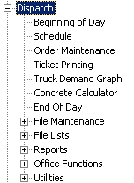 | Menu Overview
  Beginning of Day | Processing to prepare for the day. Resets appropriate values to their default status.
  Schedule | Displays the schedule screen – the heart of Keystone Dispatch.
  Order Maintenance | Entry of new orders as well as look up existing and older orders.
  Ticket Printing | Creates a single ticket “on the fly”, without the need to set up an order.
  Truck Demand Graph | (Optional feature) Displays a graph showing the truck demand over the course of day.
  Concrete Calculator | Calculates the yardage required for different shapes and dimensions.
  End of Day | Collects ticket data for transfer to the office.
  File Maintenance | File Maintenance Menu
  File Lists | File List Menu
  Reports | Reports Menu
  Office Functions | Office Functions menu
  Utilities | Utilities Menu

Beginning of Day
The Beginning of Day menu option is used to prepare the database for the upcoming day such as clearing daily totals and bringing orders forward as necessary.  Return All Trucks – if checked (default), this option finds any trucks that may not have been clocked in from the previous night (a common problem when dispatchers leave before all trucks have returned and there is no GPS system to do this automatically).  Load Office Data – used by remote stand-alone sites to load the most current information from the office.  Purge Inactive Orders – deletes any orders flagged as Inactive. | 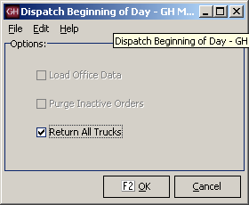  Beginning of Day

Schedule Screen
The Schedule Screen is the heart of Keystone Dispatch.
The screen is designed to give the maximum amount of information while keeping the display uncluttered.
The interface is designed to give quick access to the repetitive tasks of a dispatcher, with minimal pop-up screens and typing.
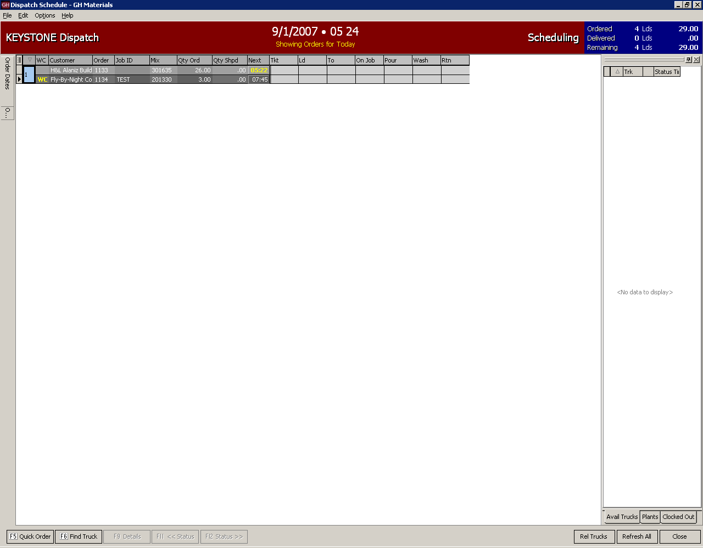
Schedule Screen

Selecting Data  The Keystone Dispatch screen has been designed to maximize the space on the screen for order information.  This is accomplished by relying on sliding menus, function keys and right-click functions.  The sliding menus work by moving the mouse over the menu bar, which causes the menu to slide out. Moving the mouse off the slide-out will cause it to shrink back to the side.  By clicking on the pushpin in the top-right corner of the slide-out, the menu remains fixed in position and will not slide back. | Schedule Screen
Selecting Dates  Keystone Dispatch allows selecting of a specific date, date range, or even time slot within a date.  Clicking the Today button will automatically show all orders for today. If this list proves too long to manage, selecting the Next button allows the dispatch to limit the screen to showing orders for the next 2, 4, 8 or 24 hours.  If there are any future-dated orders, these can be selected, allowing the dispatcher to look ahead.  The final option is to click the button near the NEXT: entry, which allows the dispatcher to view a specific time window for any current or future date and time. | 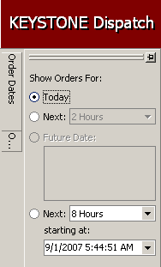  Schedule – Date Slide-out
Selecting Plants  Keystone dispatch allows for both centralized and de-centralized dispatching even within the same office by allowing each user to select which plants’ orders appear on their schedule.  Keystone also supports Plant Groups – allowing users to align plants by geography or business unit. | 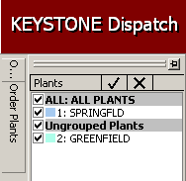  Schedule Screen – Plants Slide-out
Selecting fields  The information on the schedule screen can be customized in many ways.  One of the most popular is determining what information should appear on each line.  By default, the Plant, Will-Call Status, Customer, Order, Job, Mix, Quantity Ordered, Quantity Shipped and Next Order time are active.  Additional fields are available by clicking on the field selection icon in the top-left corner immediately to the right of the Order Dates slider.  Any field on the list can be added or removed by checking or un-checking the box, respectively.
  Field Selection Icon | 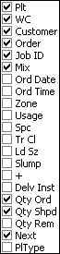  Field List
Changing field location  The default layout for Keystone Dispatch is not the only view available to the dispatcher. By clicking on a column heading and dragging it to the new desired location, the column locations change to the desired view.  In the example to the right, the fields are aligned, the dispatcher wishes to move the Qty Ordered field immediately next to the Job Id.  By clicking on the Qty Ord box and holding the mouse down while moving to the left, the field moves with it.  Green arrows indicate the current selected position of the field. If this is the desired location, simply release the mouse button. | 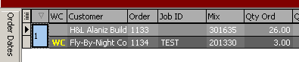Changing field location - before  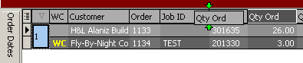  Changing field location – during  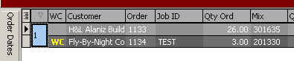  Changing field location - after

Changing order sequence
Keystone Dispatch lists orders by plant and next loading time by default.

Order Maintenance
Order Maintenance is used to enter and/or change orders in Keystone Dispatch.
When starting Order Maintenance from the menu, dispatchers can add new orders as well as edit, copy or delete existing orders.
From the Schedule Screen, an order can be added by hitting the Quick Order button. To edit an order already on the screen, right-clicking on the order brings up an option menu containing an editing option.

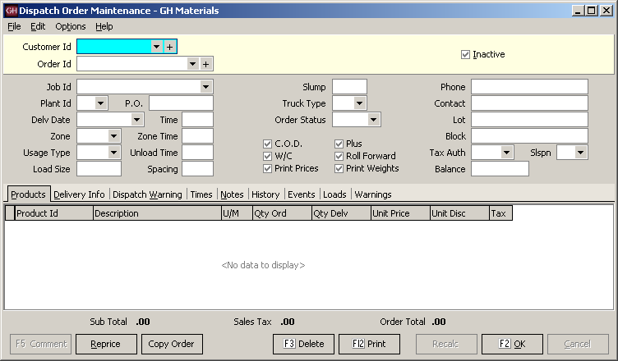
Order Maintenance Screen
Customer Id  The first piece of information Order Maintenance requires (whether adding a new order or editing an existing order) is the customer who is being billed for the material. | 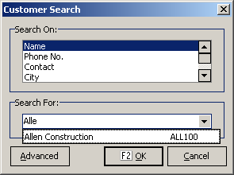  Customer Search Pop-Up Screen
Order Id  When entering a new order, this field is bypassed and the word “new” appears (Keystone Dispatch does not assign an Order Id for new orders until the order is saved).  When editing an existing order, the user can key in the Order Code if it is known.  Another option is use the dropdown and scroll through the orders (see example). | 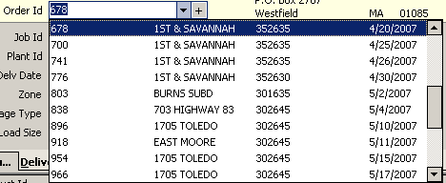  Order Id Dropdown List
Another powerful option is to do an Order Search by hitting the F4 function key.  This will bring up a screen allowing the user to search for specific orders by supplying information to target specific orders.  The most common way to look up old orders is by delivery date. A calendar is displayed in the middle of the screen. Any days that the customer placed an order appear in bold. By clicking on a date, orders for that date appear below.  In the example to the right, customer LMI has had orders 5, 9, 19, 20, 25, 26 and 30 of April. The user has clicked on April 26, so the system displays Order 741.  A range of orders can also be selected by entering the starting and ending date range in the section above the calendar.  Additional information such as Plant, Job Id and Product can also be used to filter out the orders. | 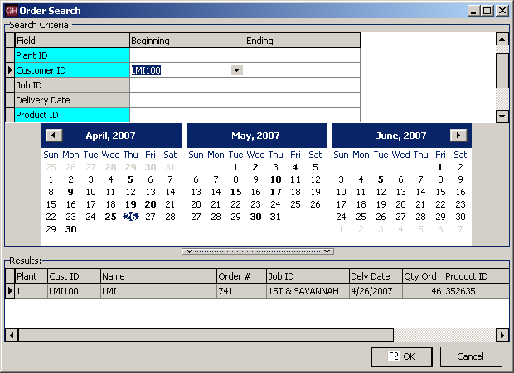  Order Search Screen
Job Id  This field contains a list of all pre-negotiated priced jobs in Keystone. By selecting one of these specially-priced jobs, materials will automatically receive the agreed upon price. This relieves the dispatcher from needing to know all special prices.  In the example to the right, LMI has two current special-priced jobs.  Note: Even if a pour is not receiving special prices, this field should be filled in, as invoices produced in the Accounts Receivable module will reference this Job Id. | 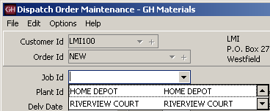  Job Id Dropdown List

Additional Data Entry Fields
Field Name | Description / Usage
Plant Id | The primary delivery plant is specified in this field. Other plants may be used to dispatch this order as well.
P.O. | Purchase Order numbers should be entered here. Note: If a specially-priced job has a PO assigned, this number will automatically be assigned when the Job Id is specified.  This field can also be used for Lot #’s for customers desiring separate invoices for each lot within a development.
Delv. Date | Enter the delivery date in this field. Delivery Dates can be entered for today or any point in the future. Any attempt to date an order in the past will generate a warning.
Time | Enter the first on-site time for this order. Keystone Dispatch will automatically calculate the batch time based on other fields entered later. The time field uses military time (eg: 3:00pm is 1500), and should be entered as a number without any punctuation.
Zone | This field indicates the delivery zone for the order.
Zone Time | This field receives its default value from the entry made in the Zone field, however may be overridden.
Usage Type | The type of pour greatly influences the time an order requires. Usage Type indicates the type of pour, and builds the discharge rate into the time estimations.
Unload Time | This field receives its default value from the entry made in Usage Type, however may be overridden.
Load Size | This is the default load size for each order. Each order can be overridden as needed, however the assumption is that each load will be the size specified here.
Spacing | This value represents how often a new should be sent to the job. If this field is left blank, Keystone Dispatch will adopt a one-at-a-time dispatch schedule, only sending out a truck when the last truck returned.
Slump | If a specific slump is required, or needs to be printed, enter the slump here.
Truck Type | For plants with both front and rear discharge mixers, this field can be used to specify a preferred mixer type.
Order Status | Open is the default order status for any current order.  Closed orders are orders which will not receive any more loads.  Completed status is assigned by End-Of-Day processing when an order’s delivered quantity matches or exceeds the ordered quantity.  Cancelled status is for orders which are cancelled prior to receiving any material.  Hold status represents orders which are not currently shipping, but are expected to resume.
C.O.D. | The COD flag is automatically set for any COD customers. This automatically triggers the printing of prices on the delivery ticket. In addition, these delivery tickets will not be subject to office re-pricing.
Plus | When an order ships enough material to match the quantity ordered, it is no longer displayed on the order stack. By flagging an order as a plus order, it indicates that the quantity ordered is more of an estimate, and these orders will remain on the schedule.
W/C | This field is used to indicate WILL CALL orders. Will Call orders appear on the schedule screen with a status indicating that it is not a firm order.
Roll Forward | Most orders entered into Keystone Dispatch are for a single day. At the end of the day, even if not completed, the orders disappear from the schedule screen.  Roll Forward orders stay on the schedule screen until their delivery quantity is met, whether that takes an extra day or an extra month.
Print Prices | Checking this box triggers the printing of prices on the delivery ticket.  Note: Some installations are set to automatically print prices on all tickets.
Print Weights | Checking this box triggers the printing of batch weights on the delivery ticket.  Note: Some installations are set to automatically print batch weights on all tickets.
Phone | This field contains the customer’s phone number. It can be changed to an on-site cell phone number if desired.
Contact | This field contains the customer’s contact name. It can be changed to the on-site foreman if desired.
Lot | This field is used for lot numbers for large development projects. In Keystone Accounting, the priority for invoices is Job Id, PO #, Lot and Block. If there is no PO # associated with a job, it is recommended that the Lot be used in the PO # field.
Block | This field tends to be used instead of Lot #, and is used for large development projects such as shopping centers or single-structure, multiple-housing units.
Tax Auth | This contains the Tax Jurisdiction where the job is located. While most jurisdictions levy sales taxes based on the delivery location, some are based on the plant location.
Slspn | This field contains the salesperson code.
Balance | This field is maintained by Keystone Dispatch and contains the running dollar balance of the order.  Note: Tickets are subject to change during billing, so it is not recommended to quote this number to customers as the current balance.

Information Tabs  Due to the very large amount of information that some orders require, tabs are used to organize the data. | 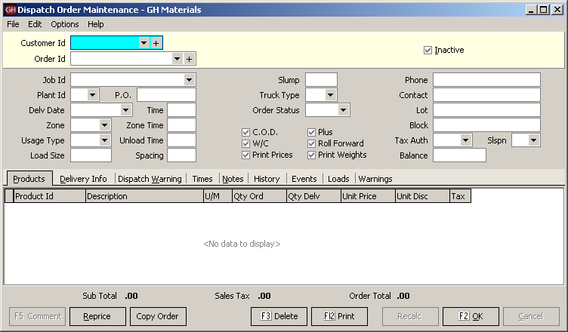  Order Maintenance Information Tabs
Products Tab  The data on this tab contains information about the material and surcharges on each truck. | 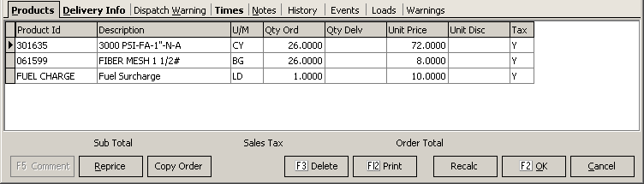  Products Tab Screen
Field Name | Description / Usage
Product Id | Enter the product(s) to be shipped in this field.
Description | The product description is filled in from the product code. Any description can be overridden, with the overridden text appearing on the ticket and invoice. This is especially useful for customer who wish to see something unusual (such as cement content) on the description without having to create a special product.
U/M | The Unit of Measure field is filled in from the product code.
Qty Ord | This field contains the quantity ordered for individual products. Some products such as a fuel surcharge or an off-hour delivery fee are assessed per load, in which case the quantity ordered will be 1.
Qty Delv | This field contains the quantity delivered so far. Keystone Dispatch automatically updates this value.
Unit Price | This is the unit price for the material. This price can vary by customer and job.  Note: The price may not appear on all systems.
Unit Disc | This is the per-unit discount for the material based on prompt payment.  Note: The price may not appear on all systems.
Tax | This field indicates if a product or service is taxable. A value of “Y” indicates sales tax will be assessed on the product/service. A numeric code (1 – 9) indicates there is no sales tax for that line.

Delivery Info Tab  This tab is used for delivery information. The Ship To fields are used for invoicing, while the Delivery Instructions are directions to the job site.  The Comments and Notes section are used for extra space that may be included on delivery tickets on request. | 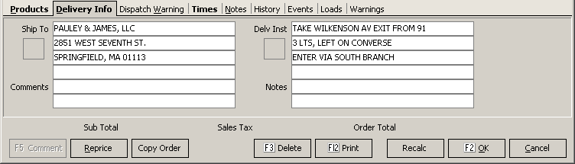  Delivery Info Tab Screen
Dispatch Warning Tab  Any entries made in here will pop-up as soon as any attempt is made to dispatch a load on the order. This can be used for important delivery instructions, changes required (additives on certain loads, etc.) or any other critical piece of information for the dispatcher.  The Show Dispatch Warning checkbox allows enabling/disabling the warning without having to clear any warning already in place. | 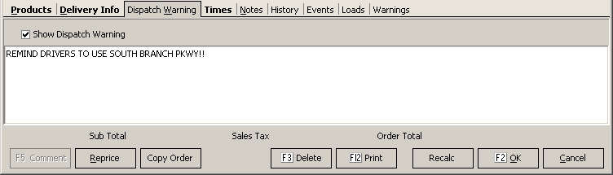  Dispatch Warning Tab Screen
Times Tab  The times tab is used as the basis for calculating the timing of events for this order. All the times on this tab will use the default values established for the plant, but may be overridden if necessary here. | 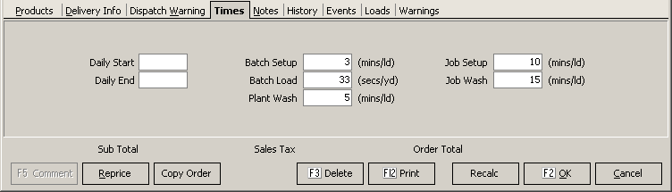  Times Tab Screen
Notes Tab  The notes tab is a free-form box which can be used to take notes about the order. None of the information on the tab will be displayed on any delivery screens or tickets. | 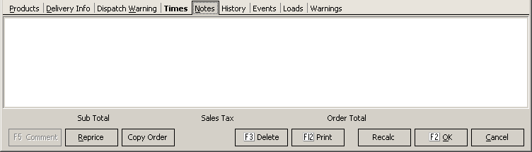  Notes Tab Screen
History Tab  The history of each order’s shipments is contained on the history tab. It contains the ticket number, date and time of each dispatched load. If a ticket is later voided, a checkbox to the right indicates the voided status.  Until end of day processing, the Dispatcher can edit any non-voided ticket by double-clicking on the ticket number. | 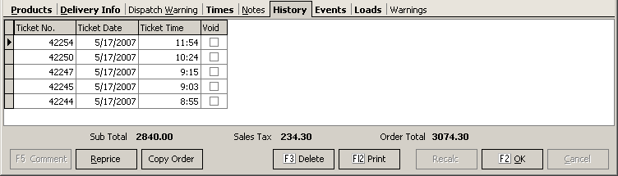  History Tab Screen
Events Tab  Any time an order is changed, the events tab logs it. In the example to the right, the load size was changed from 0 to 9 by Jeff at 11:19. Two minutes later, the order quantity was changed to 20 yards.  Several hours later, Javier apparently noticed an incorrect price in the order, and changed it from $69.00 to $68.00.  This logging takes place automatically. The Order Audit Trail report can be run to track all order events. | 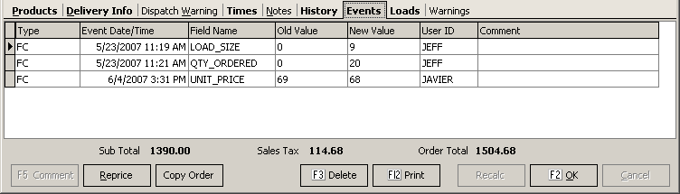  Events Tab Screen
Loads Tab  When an order is saved, Keystone Dispatch projects the individual loads required to fill the order. In the example to the right, a 26 yard order was entered with a maximum load size of 9 cubic yards at 45 minute intervals beginning at 6:00. Keystone Dispatch determined that three loads were necessary, and set the load size and schedule as shown. | 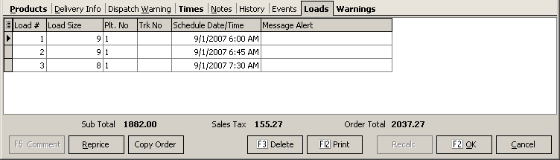  Loads Tab Screen
Warnings Tab  The Warnings tab contains messages generated by Keystone Dispatch alerting the user of changes or unusual settings.  In the example to the right, it recorded that the unit price and zone had both been changed since the order was initially entered.  If an order contains inaccurate information, this tab often helps the dispatcher find the problem quickly. | 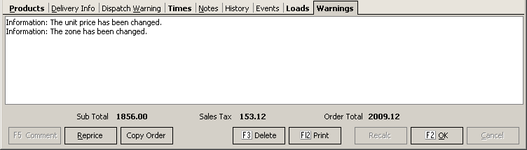  Warnings Tab Screen
Control Buttons / Function Keys | 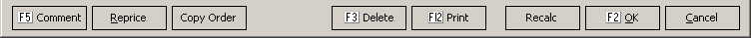  Control Buttons / Function Keys

F5 Comment
This button is only highlighted while entering data in the products tab. This allows the dispatcher to enter comments in the product area of the delivery ticket.

Reprice
Clicking this button reprices the delivery ticket based on the latest pricing available for the product, customer or job. This is especially useful when copying old orders.
Copy Order  This button allows the dispatcher to bring the same order information from one day to another or one customer to another without re-keying and while allowing changes.  After bringing up the order to be copied and hitting the Copy Order button the screen to the right appears allowing the dispatcher to choose the customer to copy the order to.  The order is then copied, and the dispatcher can make changes as necessary before saving it.  Note: It is recommended that the dispatcher click the REPRICE button after copying an order if the prices may be subject to change from the original order. | 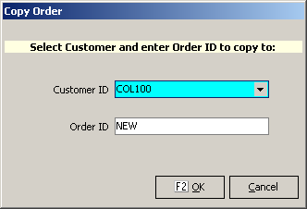  Copy Order Screen

F3 Delete
The Delete button erases the order from the system completely. Once a load is shipped on an order, it cannot be deleted and should instead have its status changed.

F12 Print
This button prints a summary of the order, with product information, delivery instructions and estimated times.
Note: The layout of this print-out can be customized if necessary.

Recalc
When an order is entered and saved, Keystone Dispatch projects the loads necessary to complete the order.
If changes are made to the quantity ordered or load sizes, this can change the number of loads required to complete the job.
This button is used to recalculate the projected loads to complete the order.

F2 OK
This button saves all changes.

Cancel
This button cancels changes made to the existing order, or cancels the entire order if it had not already been saved.

Ticket Printing
The Ticket Printing option from the Keystone Dispatch menu is intended for single-load orders that are not scheduled.
This streamlined method of generating a delivery ticket does not require setting up and order in Order Maintenance. Tickets generated in this manner are currently not included in the Schedule Screen.
For information about the data that must be entered into the fields, please see page 21 (Additional Data Entry fields).

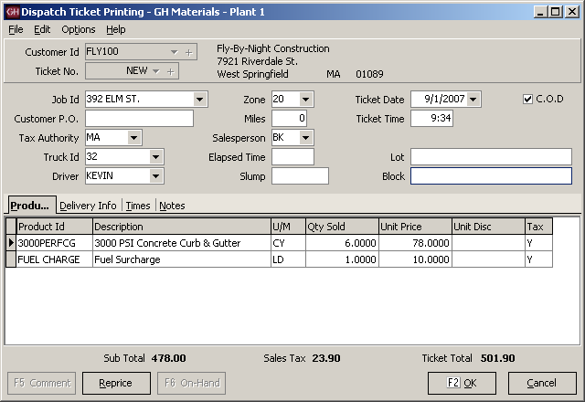
Ticket Printing Screen

Truck Demand Graph
(Optional Feature)

The Truck Demand Graph is designed to be a visual aid in projecting the number of trucks required throughout the day to meet the scheduled demand.
The modest Saturday example below shows a firm need (represented by the blue bar) for one truck at 5:00, increasing to three trucks from 6:00 and 7:00, decreasing to two trucks at 8:00 and only one truck needed for 9:00. There is also the potential need for a truck to service a will-call order (represented by the green bar) from 7:00 through 8:00.
Lines are also plotted to represent the home plant capacity (number of trucks assigned to the plant), as well as the current capacity, which may rise or fall as trucks are loaned or borrowed between plants.
This program allows for three individual graphs, allowing the Dispatcher to monitor three separate sets of demand, as well as a consolidated graph, which shows overall demand at all selected plants.
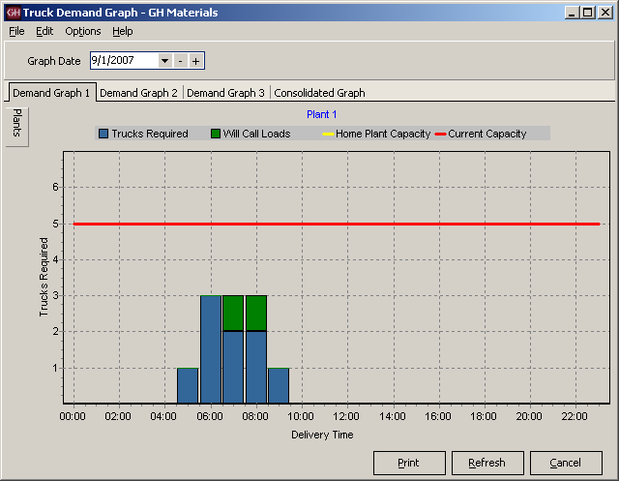
Truck Demand Graph Screen

Plant Selection  To determine which plants appear on each tab, begin by selecting the tab desired (in the example to the right, it is Demand Graph 1).  To assign plants to this tab, move the mouse over the tab labeled Plants (see figure 1) - clicking is not required.  A menu will slide out (see figure 2) allowing the user to select which plants should be shown on the graph.
  Plant Slider Bar – Fig. 1 | 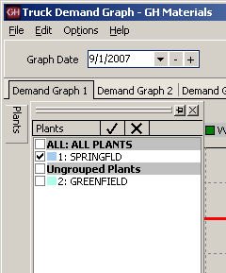  Plant Slider Bar – Fig. 2
Graph Settings  The Truck Demand Graph can be customized by the dispatcher to give the | 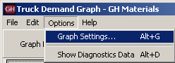  Changing the Graph Settings
Projection Hours determines how much of the current day to show. Entering a two in this field will show the graph for the current time through the next two hours.  Slot Length determines the amount of time indicated by each graph bar. In the example above, 60 minute slots were used.  Turnaround Time is the amount of preparation time required for a returning truck to be ready for its next load. For example, if a truck is returning at 8:05, it may not be ready to receive its next load for 5 minutes, so a load scheduled to depart at 8:07 couldn’t rely on using that truck, while a load a 8:15 could.  Graph Refresh Rate is how often the Truck Demand Graph is recalculated.  Will Call Color is the color used on the graph to differentiate firm orders from will-call orders. | 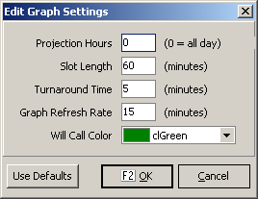  Graph Settings Screen
Diagnostic Data  The graph is plotted based on the projected loads generated from Order Maintenance.  By clicking on Options and Show Diagnostics Data, additional tabs will appear allowing the Dispatcher to review the calculated data. | 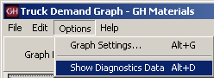  Showing the Diagnostics Data
The demand is determined by adding new orders within the time slot to existing loads already in transit.  From this number, deductions are made for trucks returning in time to take another load within the time slot.  For each time slot, a total is generated for the following categories:  Turnaround is the number of trucks that are returning within a time slot that will be ready to take another load within that time slot.  Inbound represents the number of trucks that are returning to the plant, but will not be back in time to take another load within the time slot.  Outbound is the number of new loads that are being dispatched within that slot.  Required is the number of firm orders being dispatched within that slot.  Will Call is the number of will-will orders being dispatched within that slot.  The Depart Data and Return Data contain the data from each load (ordered by departure time and return time, respectively).  The Diagnostics tabs will disappear the next time the Truck Demand Graph is refreshed. | 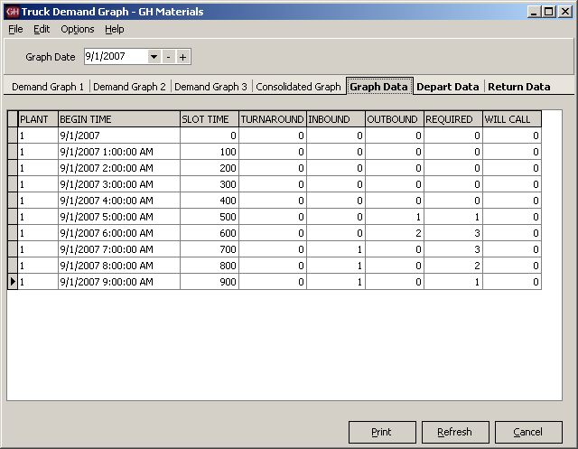  Diagnostics Data Screen
Timeslot Order detail  By double-clicking a graph bar on the Truck Demand Graph, the dispatcher can view all activity within the timeslot.  A screen will open with an upper and lower half representing Outbound and On Job orders respectively.  Outbound Loads  These are orders that are being dispatched within this time slot. These orders are color-coded to represent how the order is serviced.  A white entry means that a new truck is required – there are no returning trucks within this timeslot which can dispatch this order in time.  A green entry means that there is a truck returning within this time slot which will be able to take the load and depart on time.  On Job Loads  The bottom half represents trucks that are already on jobs, as well as trucks that are returning to the plant. These entries are also color-coded.  A white entry represents a truck that is on a job and is not scheduled to return within this time slot.  A yellow entry indicates an truck that is returning to the plant within this time slot, but will not be back in time to  A green entry is used to show a truck that is returning within this time slot that will be back in time to take another load within this timeslot. | 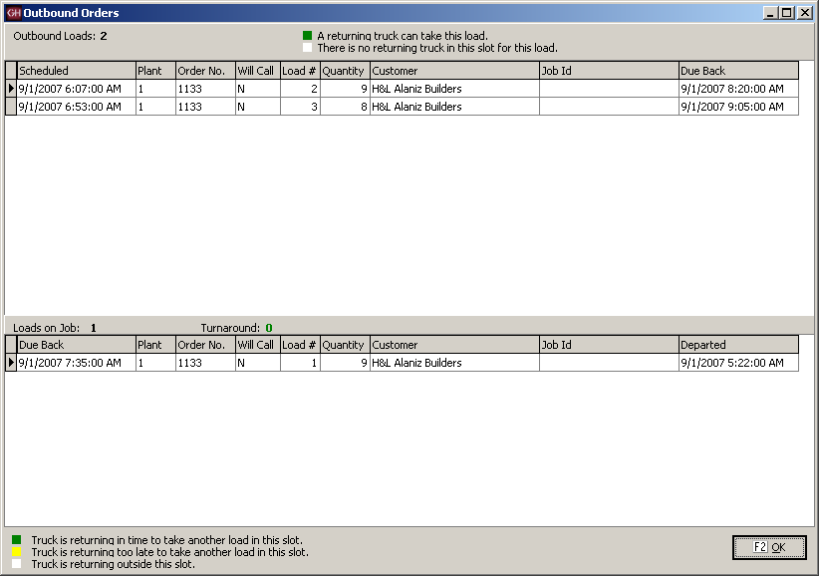  Timeslot Order Detail

Concrete Calculator
Like most dispatch systems, Keystone Dispatch is equipped with a concrete calculator.
Unlike other dispatch systems, Keystone Disapatch's concrete calculator can be used to calculate both the individual pieces of the job as well as the total yardage of a job.
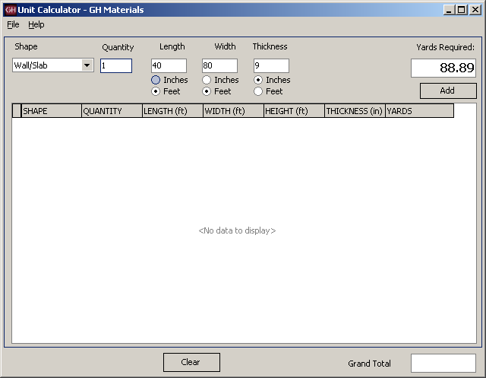
Concrete Calculator Screen

Calculating volume  Calculating the volume of material needed is as simple as determining the shape, quantity and dimensions.  As the numbers are entered, the yards required is calculated in displayed (approximately cubic yards), allowing the dispatcher to change dimensions quickly. | 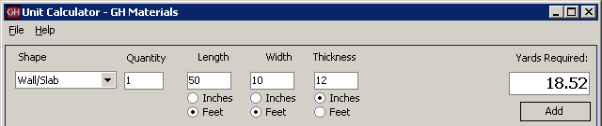  Calculating Volume – individual component
Job Totaling  What is particularly useful with Keystone’s Concrete Calculator is the ability to enter each component individually, but have them tallied for a job total.  In the example to the right, in addition to the 40 x 80 slab, two additional slabs, measuring 20 x 10 are also required.  After entering the dimensions for the larger slab, the dispatcher clicked on the Add button, then entered the second dimensions and added that as well.  The result is shown to the right. All three slabs are shown, with the grand total of 96.3 yards required.  The totals can be cleared by clicking the Clear button.  The Concrete Calculator also accepts NEGATIVE quantities to yield negative yardage. This can be helpful in calculating openings in a shape.  In the example to the right, a wall measure 50 feet by 10 feet and 12 inches thick requires about 18.5 cubic yards.  If there are ten windows measuring 3 feet by 5 feet, that’s approximately 5.5 cubic yards of material not required. By doing the first calculation, then doing the window calculations using -10, the accurate figure of 13 yards is derived. | 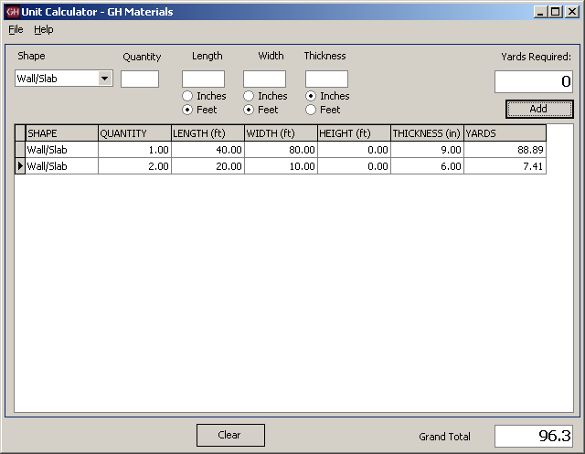  Job Totaling  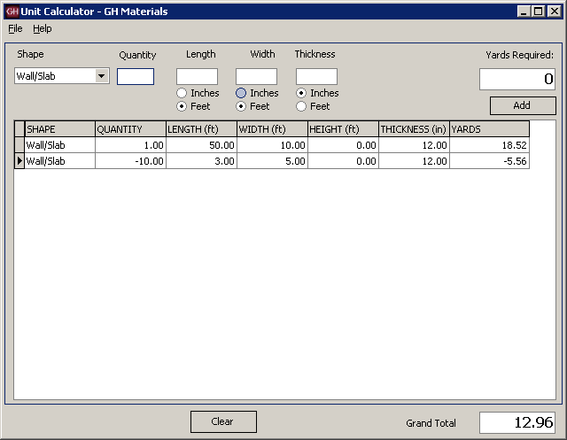
Other Shapes  There are many shapes supposed by the Concrete Calculator, each with different measurements. Most measurements can be entered in either feet or inches as needed. In addition to Wall/Slab, the following shapes are available:  Wall/Slab – Quantity represents the number of slabs, while Length, Width and Thickness are measurements of the slab itself.  Column – Quantity represents the number of columns required. Measurement type can be set to either Diameter or Radius of the column with the appropriate value, as well as the height of the column.  Pipe – This unit works similarly to column, except there is an additional field called thickness which represents the thickness of the walls of the pipe.  Foundation – This shape is designed to be a shortcut in calculating the amount of concrete required for a calculation. It requires the Length, Width and Height of the four walls, as well as the thickness of the wall. The calculation does not include the slab.  Steps – This shape is used for building a solid staircase. The quantity represents the number of individual steps. Tread Width, Tread Height and Width of the steps are also required.  Triangle – This calculation requires Length and Width and Thickness of the concrete.  Cone – Cone calculation are similar to column calculations, with a volume reduction  Pyramid – Length, Width and Height measurements are required for this shape.  Sphere – The measurement type (diameter or radius) and accompanying measurement is all that is required for the solid sphere.  To derive the area for a hollow sphere, calculate the volume based on the outer measurement, and then use a negative value for the inner measurement. | 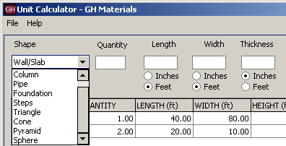  Shape Selection Screen

End of Day
End of Day processing serves several purposes in Keystone Dispatch.
It’s primary function is to prepare the delivery tickets export to the Keystone Accounts Receivable system. Once tickets are exported, they may no longer be re-printed, edited or voided. While the delivery tickets are no longer available to the dispatcher, the orders that generated the delivery tickets remain in the system.

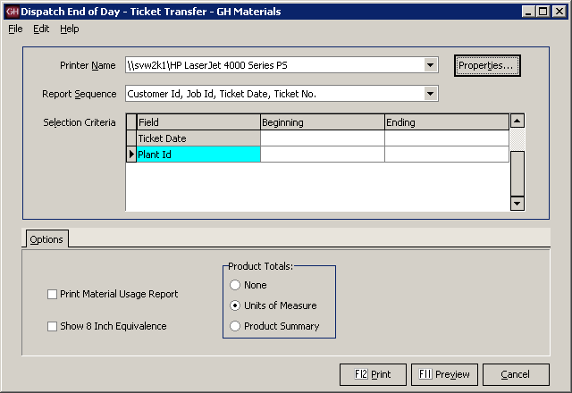
End of Day Screen

Report Sequence Options  The End of Day prints a copy of all tickets. By changing the Report Sequence, dispatchers can generate the report in the most appropriate order for their needs. | 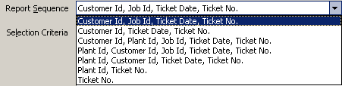  Report Sequence Screen

Additional Report Options
By checking the appropriate selections on the Options tab, additional information can be included on the report.

Material Usage Report
Checking this box generates an additional report at the end of the ticket list showing the raw material usage (sand, stone, cement, etc.)

Show 8 Inch Equivalence
Primarily used for block & brick, this generates a report of block in 8 inch equivalences.

Product Totals
This optional report can generate a summarized or detailed list of products.
When Units of Measure is selected, End of Day generates a grand total of yardage.
When Product Summary is selected, the report contains each product, the total of each product, as well as a grand total.

Menu Navigation – File Maintenance
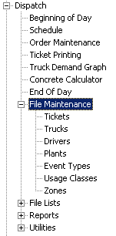 | Menu Overview
  Tickets | Dispatchers can edit delivery tickets using this option.
  Trucks | Using Truck Maintenance, users can add new trucks, as well as changing status, reporting and defaults of existing trucks.
  Drivers | Editing of driver information is done through this option.
  Plants | Plant setup values are stored in Plant Maintenance. Values here have a major impact to Keystone Dispatch and great care should be taken when making changes.
  Event Types | Changes to an order are tracked as events. The type of changes tracked are discussed here.
  Usage Classes | Different types of pours (eg: slab, curb, etc.) and the time required to service the job are defined within Usage Classes.
  Zones | Delivery Zones and their impact on transit times are reviewed here. For additional information on Delivery Zones, see Appendix A (see page 76).

Ticket Maintenance
Delivery tickets are created when the load is batched. This does not necessarily mean the information on the ticket is accurate or complete. Ticket Maintenance allows dispatchers an opportunity to correct delivery tickets. Information can be changed (eg: correcting Job Id), or new products added (eg: excess on-site time).
The editing screen looks identical to the screen opened when the delivery ticket is first created to make editing easier.
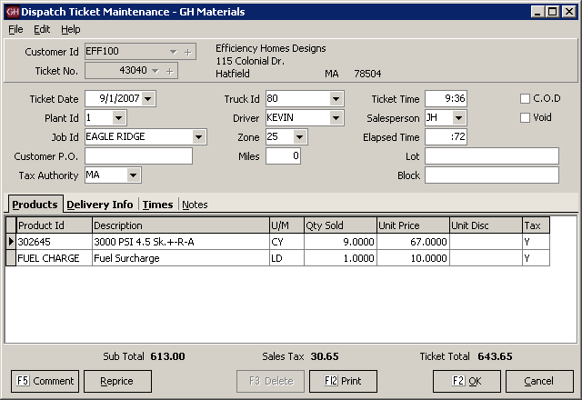
Truck Maintenance Screen

Truck File Maintenance
Keystone Dispatch must have some basic truck information in order to run the dispatching schedule.
The only three required fields are Truck Id, Home Plant and In Service.
It is strongly recommended to fill out the Default Driver and information on the Vehicle Info tab.
Tare Weights and Legal Max are used more for the Aggregate and Block functions. Customer Id allows a truck to be tied exclusively to a customer, while Owner Id is used for third-party haulers.

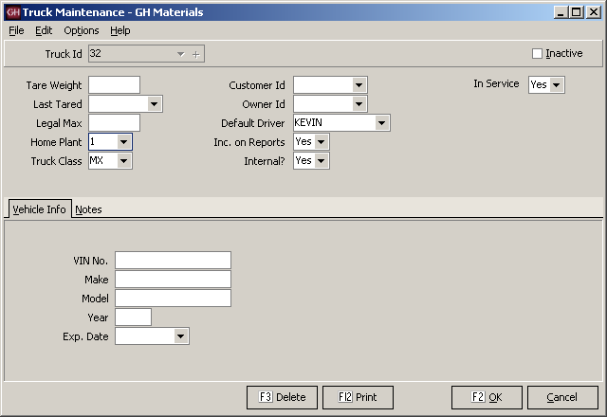
Truck Maintenance Screen

Truck Maintenance Data Entry Fields
Field Name | Description / Usage
Truck Id | Truck Id is the way Keystone Dispatch displays trucks. This field may be up to five characters long.
Tare Weight | Tare Weight is typically used for aggregate operations where scales are used to determine the amount of material loaded on a truck. This field is unnecessary for concrete operations.
Last Tared | This field contains the last date the truck’s tare weight was established.
Legal Max | Also intended more for aggregate operations, once the Maximum Legal Weight of the truck is entered here, Keystone will not allow any overloaded truck to be ticketed.
Home Plant | This represents the plant where the truck is typically based. Each day, the Beginning of Day processing returns a truck to its home plant (if it were loaned to another plant)
Truck Class | Truck Class is a method of differentiating trucks. Operations which operate both front and rear discharge mixers typically use Truck Class to distinguish the trucks.
Customer Id | Customer Id is used only when a truck is owned by a customer and used exclusively for that customer’s benefit. This is more typical of aggregate operations.
Owner Id | Owner Id is used when a truck is owned by a third-party and is rented or leased. This permits truck reports by owner.
Default Driver | While any driver can be assigned to a truck at any time, the default driver is the assumed driver of a truck unless otherwise specified.
Inc. on Reports | All trucks are included on trucking reports unless this field is set to N, and typically only for customer-owned trucks.

Internal
In Service | The In-Service setting is very important in determining the pool of trucks available to dispatch. If a truck is out of service, it will not appear on the schedule screen.
VIN No. | The Vehicle Identification Number is not required for dispatch purposes, but useful to have stored in the database.
Make | The make of the vehicle.
Model | The model of the vehicle.
Year | The production year of the vehicle.
Exp. Date | Expiration date is used to specific the registration expiration date, allowing administrative to easily browse upcoming expiring registrations.

Driver File Maintenance
While driver setup is not required for Keystone Dispatch, entering the information will allow for enhanced reporting capabilities.
The Driver Id must be unique for each driver, but does not necessarily have to be their employee number. In the example, the Driver Id is Kevin, while his employee number is WES220.
The only required field is the home plant, however additional information should be provided whenever possible.
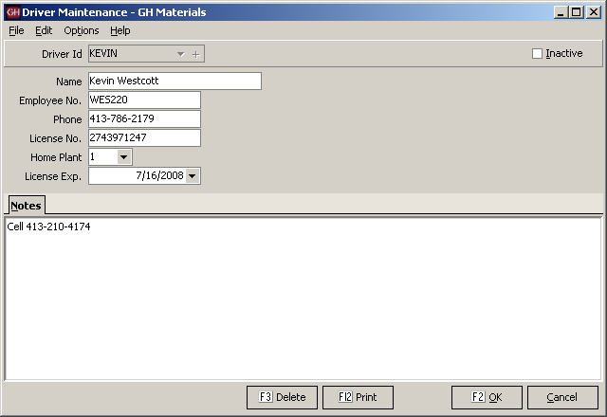
Driver Maintenance Screen

Plant File Maintenance
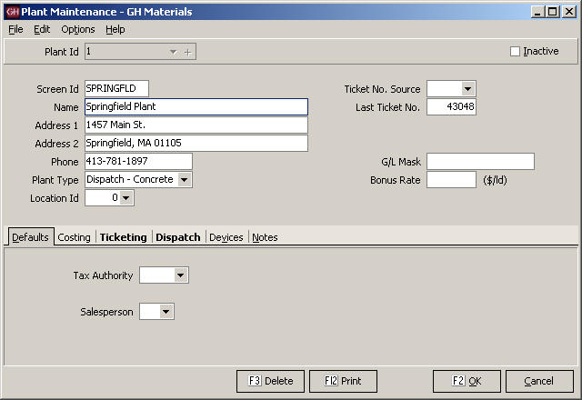
Plant Maintenance Screen

Plant Type Setup  The first step in setting up Keystone Dispatch is to indicate which plants use it.  It is important to select Dispatch – Concrete. There is an option of Concrete, however this setting is used for concrete plants that will not be using Keystone dispatch (eg: a small satellite plant).  Click OK after making your changes so the additional tabs will appear. | Plant Maintenance Screen
Ticketing Setup  The Print Batch Weights checkbox sends a signal to the batch computer that batch weights are required on the delivery tickets.  Ticket Form should be set up you’re your GivenHansco installer.  Batch Mix is used when a truck will be carrying a non-concrete load (eg: a mixer full of gravel). This product will be sent to the batch control along with the non-concrete product on the second delivery line of the ticket.  Load Size is the default load size for orders from this plant. | 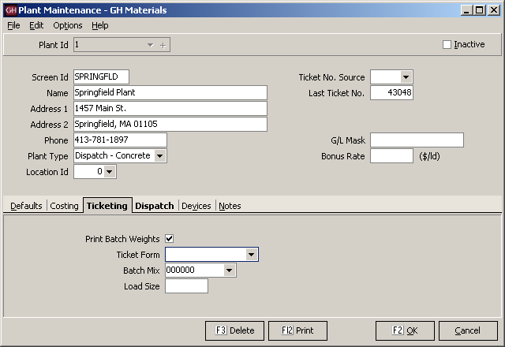  Ticketing Tab
Dispatch Setup  Plant Color is used to distinguish each plant’s schedule and trucks. There is a large choice of colors to choose from. It is strongly recommended that light colors are selected, and not shades of Red or Yellow, as these colors are used to indicate warnings to the dispatcher.  Reschedule Threshold is not implemented at this time. When implemented, this acts as an allowance when scheduling orders around your plant’s operating hours.  For example, assume a plant is open until 5:00pm. If an order’s schedule has the last order leaving the plant at 5:15 and the reschedule threshold is 30 minutes, it will schedule the load for today.  If your reschedule threshold is set to 10 minutes, this final load would fall outside the threshold, and be scheduled for tomorrow morning.  The remaining fields are used to set the default values in the plant when taking orders.  Batch Capacity is the maximum yardage that can be batched at one time.  Open Time / Close Time represent the plant’s operating hours. No loads will be scheduled prior to the opening or after the closing time without requiring the dispatcher to approve the change.  The remaining fields are used to establish default times for any loads dispatched from this plant. | 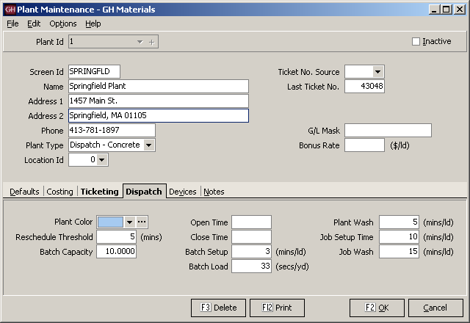  Dispatch Tab
Device Setup  This section contains a list of all devices that Keystone Dispatch will be using for this plant.  It is very important that the correct devices are checked. These settings will be determined at installation by your GivenHansco installer.  Never modify these settings except as directed by GivenHansco support. | 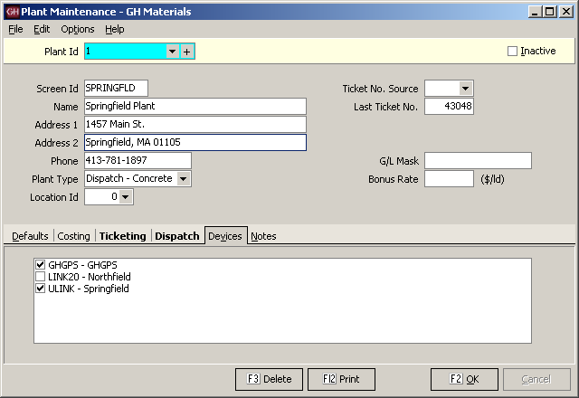  Devices Tab

Event Type Maintenance
Under the Keystone order screen events tab, changes to the order are automatically tracked. Any time a value is changed an event is generated. If an order is cancelled, this too is tracked.
Some dispatchers may wish to record additional information in this events tab. Before doing so, the type of event they are recording must be set up in Event Type Maintenance.
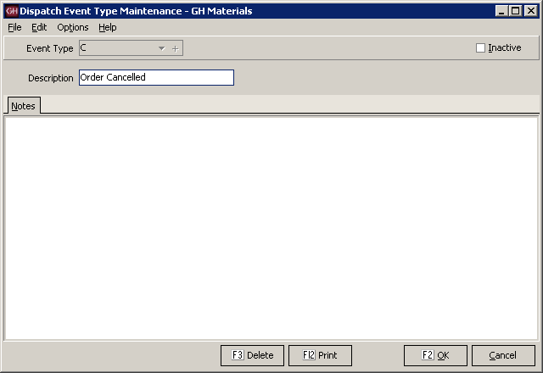
Usage Class Maintenance Screen

Usage Class Maintenance
To assist in projecting the duration of each pour, Keystone Dispatch requires information about the type of pour.
Some standard usages and discharge rates area are pre-defined within Keystone Dispatch, however these existing entries may be modified, as well as accepting new entries.
Note: The Unload Rate is in seconds per yard, not minutes.
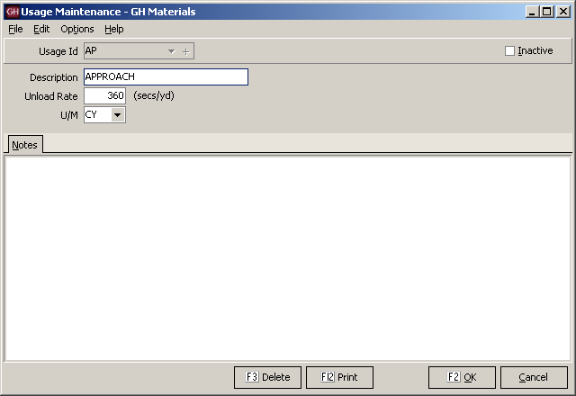
Usage Class Maintenance Screen

Zone Maintenance
Once a method is determined for establishing delivery zones, Zone Maintenance is used to enter each zone as well as the one-way time it takes to reach the zone from each plant.
When keying in orders, Dispatchers enter the delivery zone and Keystone Dispatch calculates the anticipated transit time to and from the job.
Identification of delivery zones tends to fall into three basic categories, each of which is explained below:

Time-based zones are established based on the delivery time from a given plant. There are no charts to consult, and it is easy to set up. Simply create different zones based on your delivery radius and key in the value. The values will be the same for all plants, as the zone IS the time required to get to a location. | 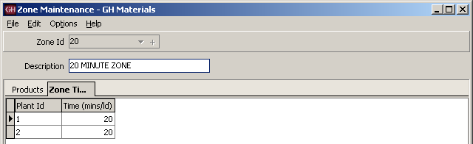  Zone Maintenance Screen – Time-based zone
Delivery-based zones are established based on the delivery area. Each possible delivery location is established, with the delivery time required entered for each plant.  In the example to the right, you can see that Hatfield is 40 minutes from plant 1, but only 20 minutes from plant 2. | 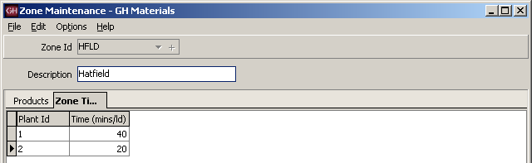  Zone Maintenance Screen – Delivery-based zone
Map-based zones are established based on a map which is shared between plants.  In the example to the right, you can see that the area in map grid C2 is 45 minutes from plant 1, but only 15 minutes from plant 2.  It is also possible to use a custom map, based on terrain, speed limits on roads and traffic considerations. | 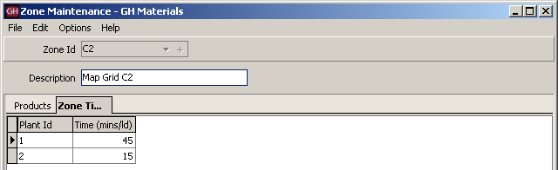  Zone Maintenance Screen – Map-based zone

Menu Navigation – File Lists
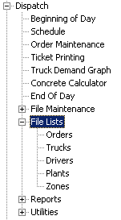 | Menu Overview
  Orders
  Trucks | Using Truck Maintenance, users can add new trucks, as well as changing status, reporting and defaults of existing trucks.
  Drivers | Editing of driver information is done through this option.
  Plants | Plant setup values are stored in Plant Maintenance. Values here have a major impact to Keystone Dispatch and great care should be taken when making changes.
  Zones | Delivery Zones and their impact on transit times are reviewed here. For additional information on Delivery Zones, see Appendix A (see page 76).

Orders List  The Orders List is a multi-purpose report. It can be used to run history reports, or used to project ahead. It can be used to review plant, date and/or customer order activity, including products and even raw materials. | 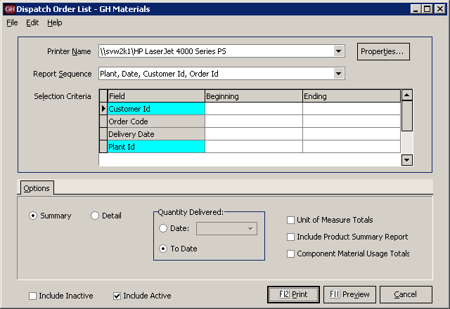  Orders List Screen
Report Sequence  The Order List can be sorted in varying ways depending on the needs of the report. | 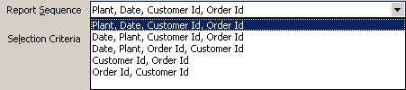  Orders List – Report Sequence Dropdown List
Summary / Detail  Summary mode reduces each order to a single line entry, allowing a short report containing basic order information.  The detailed report lists all products on each order within the report. | Summary / Detail checkbox
Unit of Measure Totals  Check this box to print yardage totals. | Additional reports checkboxes

Product Summary Usage
Check this box to print a list of products sold.

Component Material Usage
Check this box to print a list of raw materials requirements for the mixes on the report.
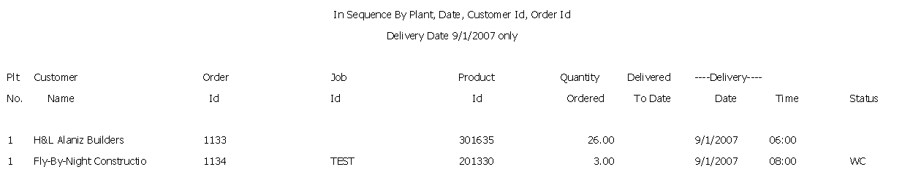
Order List Summary
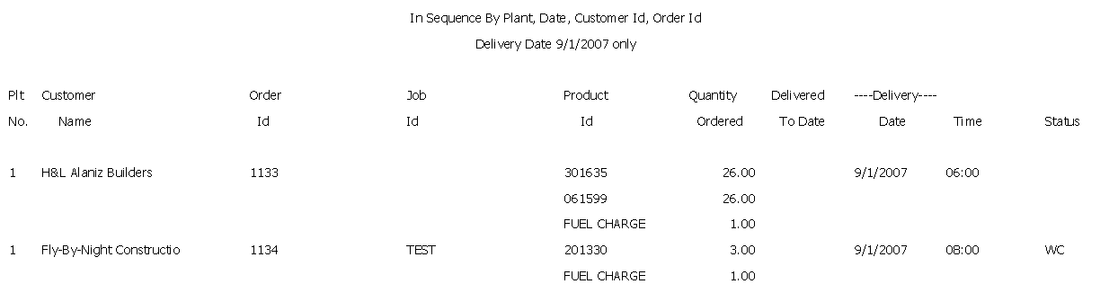
Order List Detail

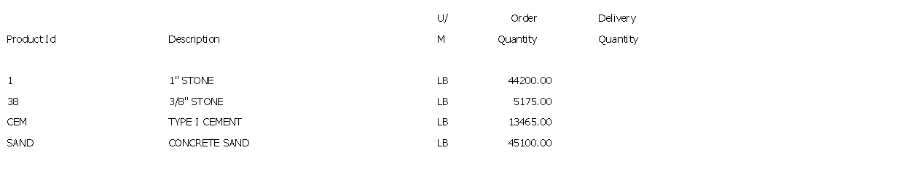
Order List – Material Usage listing

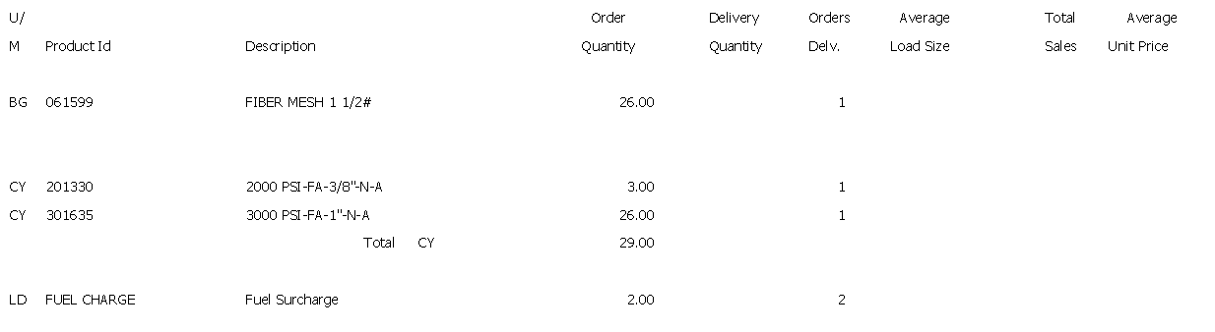
Order List – Product Totals listing

Truck List  The Truck List is used to display truck information based on user selection (plant, customer, etc.)  The sample below is a list of all trucks in plant 1. | 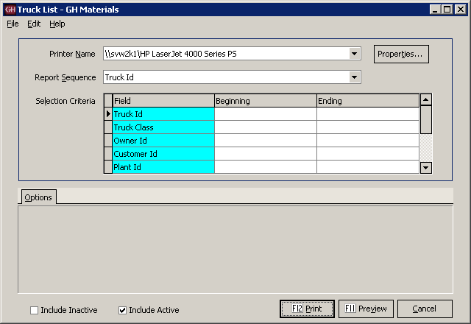  Truck List Screen
Report Sequence  The Truck List can be sorted in varying ways depending on the needs of the report.  Owner Id and Truck Id is a very useful sequence when calculating payments for third-party haulers. | 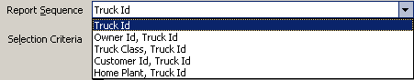  Truck List – Report Sequence Dropdown List
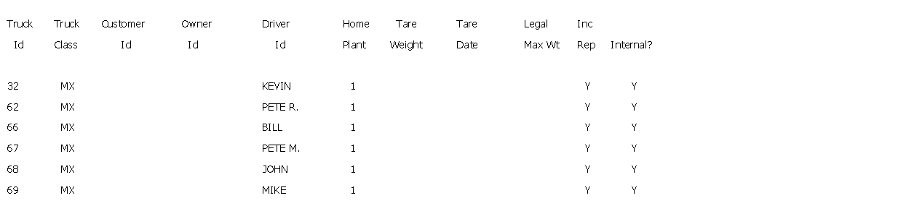
Truck List

Driver List  The Driver List is used to display driver information based on user selection such as driver, plant, or vendors (third part haulers).  The sample below is a list of all drivers in plant 1. | 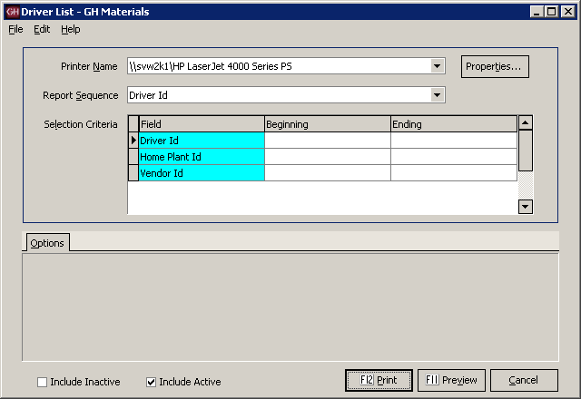  Driver List Screen
Report Sequence  The Driver List can be sorted in varying ways depending on the needs of the report. | 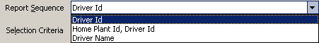  Driver List – Report Sequence Dropdown List
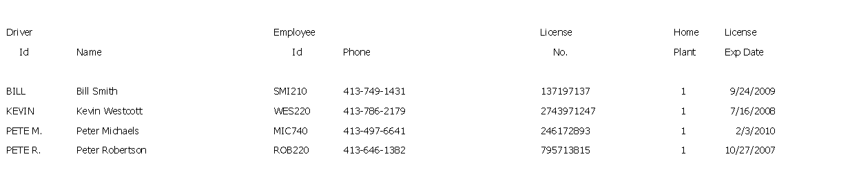
Driver List

Plant List  The Plant List is used to display plant setup information.  Plant information has far-reaching effects throughout the system, so the print options tab offers selections to list the criteria needed.  In Summary form, it simply prints one line per plant, essentially as a contact sheet.  In Detail form, it adds the address information, but remains primarily a contact sheet.  The Accounting settings include information on G/L, invoicing, ticketing and basic costing.  The Dispatch settings include the default settings and times for dispatch as well as any GPS settings. | 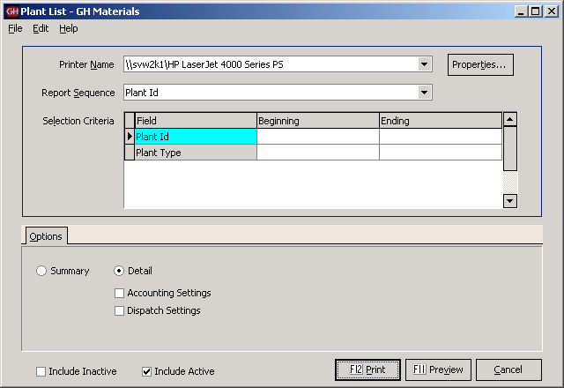  Plant List Screen
Report Sequence  The Plant List can be sorted in varying ways depending on the needs of the report. | 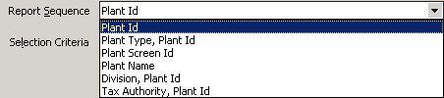  Plant List – Report Sequence Dropdown List
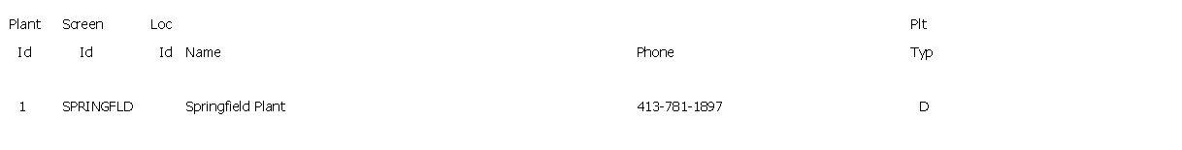
Plant List Summary
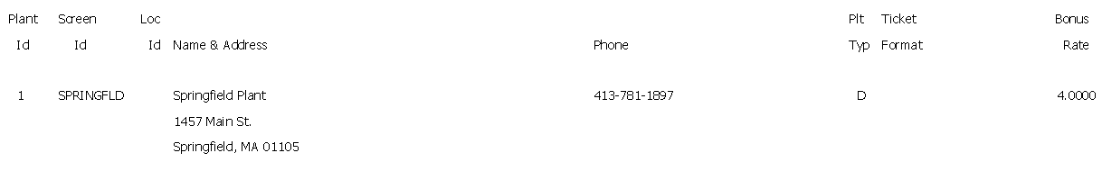
Plant List Detail
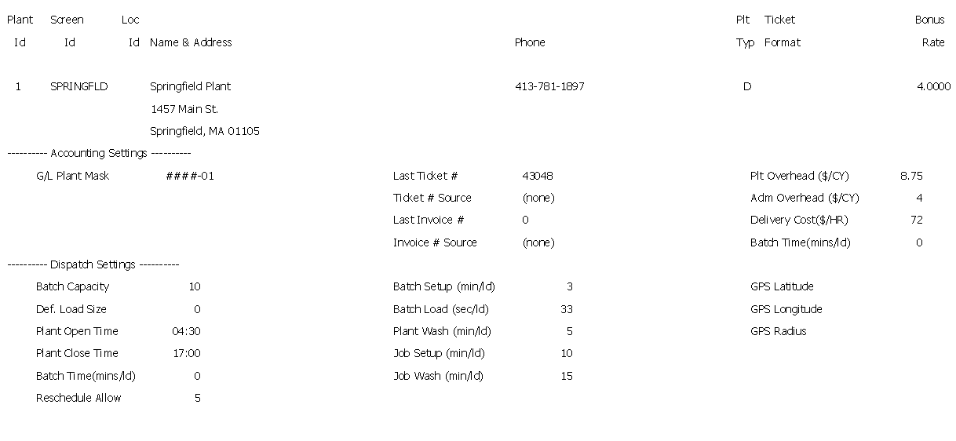
Plant List – Detail with Accounting & Dispatch Information

Zone List  The Zone List is used to display zone information. Because Keystone Dispatch uses Zones not only as a function of timing (calculating time to and from a location), but as a pricing mechanism as well, the report focuses on the more complex (pricing) element.  The sample below is based on a time-base delivery zone system, where the zone code represents the one-way time to the job. | 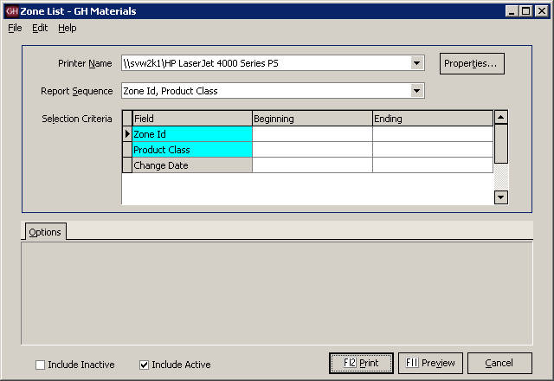  Zone List Screen
Report Sequence  For dispatch purposes, sorting by Zone Id is more useful than Product Class, which is used more as a function of pricing. | 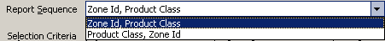  Zone List – Report Sequence Dropdown List
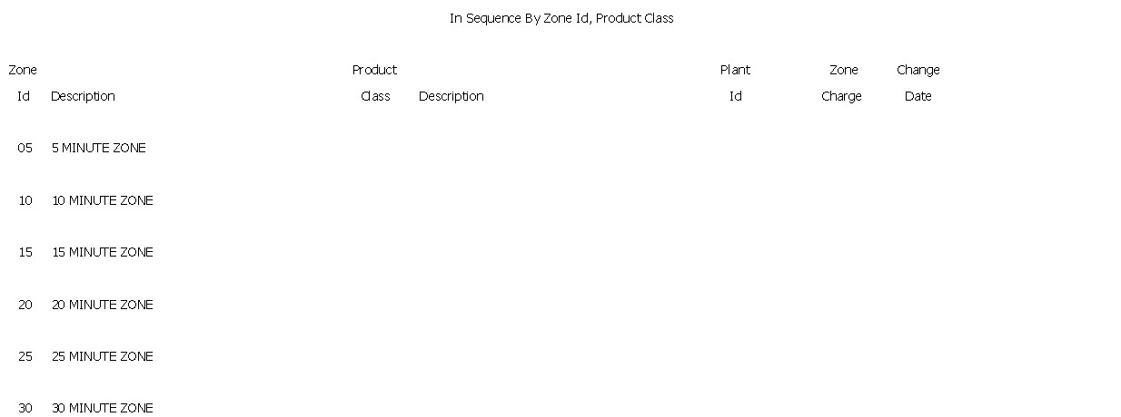
Zone List

Menu Navigation – Reports
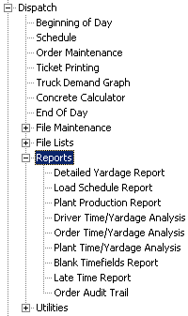 | Menu Overview
  Detailed Yardage | Generates a list of all current and past delivery tickets, including material purchased and quantities, ordered as needed.
  Load Schedule | Prints a list of all loads scheduled for a particular plant, date, order or customer.
  Plant Production | Reports load count, material quantities and average load size by plant.
  Driver Time/ Yardage | Details the actual and elapsed time of each ticket, broken down by driver.
  Order Time/ Yardage | Details the actual and elapsed time of each ticket, broken down by order and/or customer.
  Plant Time/ Yardage | Details the actual and elapsed time of each ticket, broken down by plant.
  Blank Timefields | Lists all tickets with missing times in any phase of the delivery as specified by the user.
  Late Time Report | Reports all deliveries that exceeded their allotted delivery time.
  Ticket Time Analysis | Reports all tickets and their performance in meeting scheduled delivery times (for any given phase of ticket delivery).
  Order Audit Trail | Generates a list of all changes made to order(s) based on criteria specified.

Detailed Yardage Report  The Detailed Yardage Report lists all delivery tickets (current and history) based on the selection criteria.  This report can be used to measure plant, productivity, customer activity (overall or by job) within any date or plant range desired. | 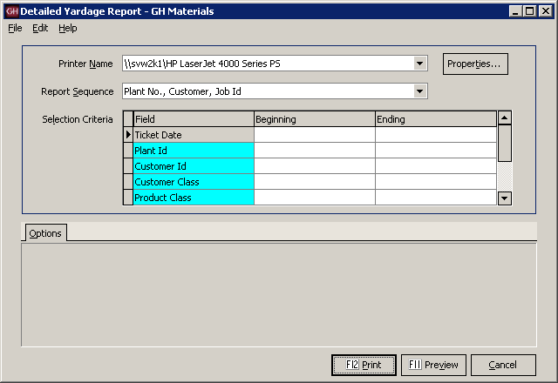  Detailed Yardage Report Screen
Report Sequence  When looking up information about by customer, the second option works best. The other options are for reporting on plant productivity. | 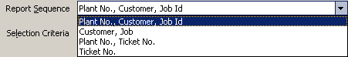  Detailed Yardage Report – Report Sequence Dropdown List
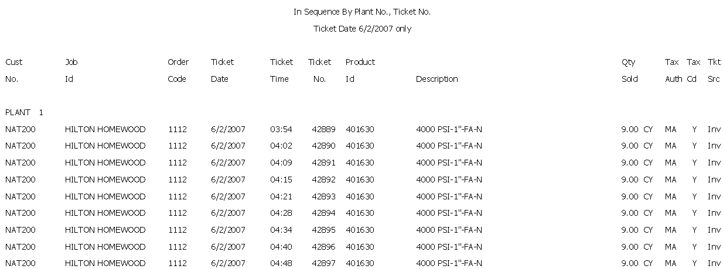
Detailed Yardage Report

Load Schedule Report  The Load Schedule Report gives insight into each delivery load. It can be run to review the past, current day or future orders.  Individual load appear with their most recent status (note: historical reports will show ARPLT (arrive plant) for all orders).  Current deliveries (where the truck has not returned) will appear in italics and the return time is projected.  Completed deliveries use the actual return time. Any order that returned late will appear with an asterisk if it falls outside the Late Tolerance value.  Additional subtotals are available, such as the unit of measure totals, product summary and component (raw material) usage. | 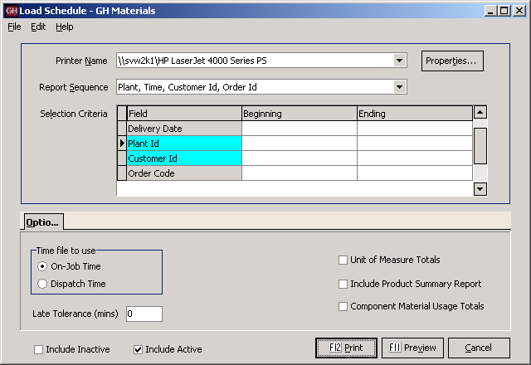  Load Schedule Report Screen
Report Sequence  When looking up information about by customer, the second option works best. The other options are for reporting on plant productivity. | 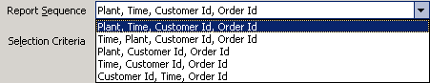  Load Schedule Report – Report Sequence Dropdown List
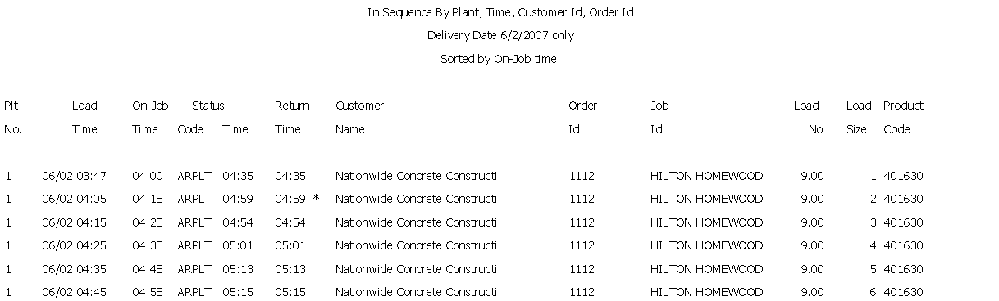
Load Schedule Report

Plant Productivity Report  The Plant Productivity Report is designed to show loads shipped, quantity sold and average load size for any given plant, broken out by mix.  The example below shows a sample report for the week of 5/13/2007. | 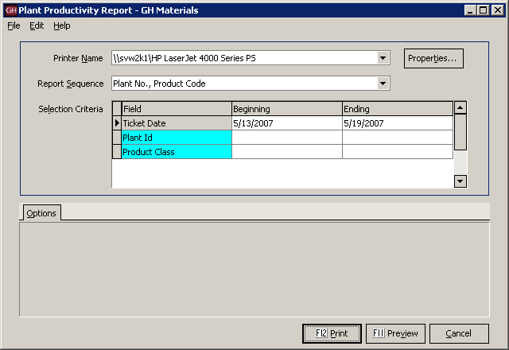  Plant Productivity Report Screen
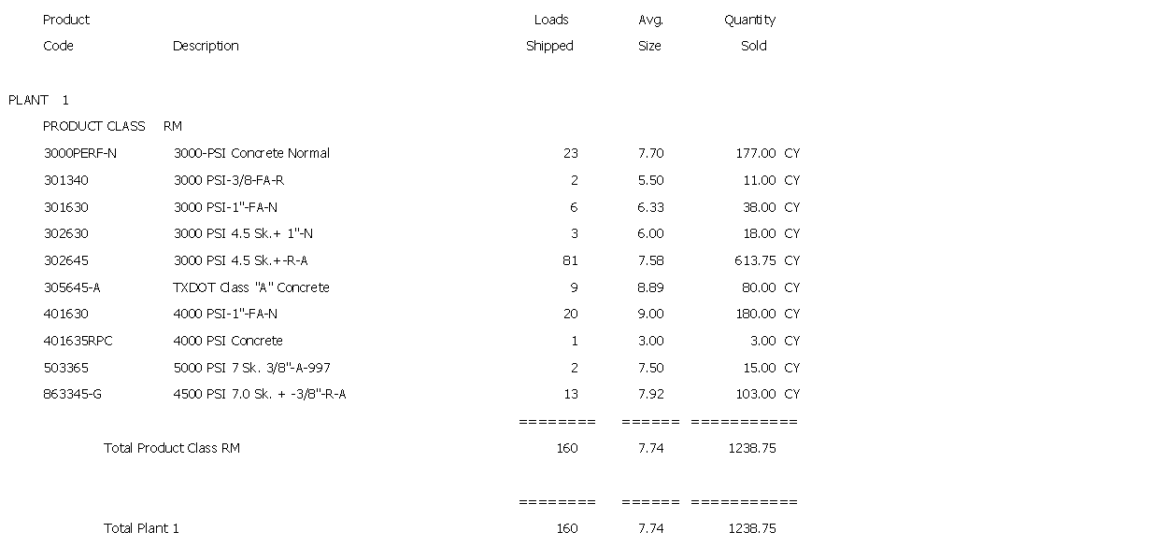
Plant Productivity Report

Driver Time/Yardage Analysis  This report is designed to review the status times of each driver’s ticket. It is intended to show driver productivity.  There are two reporting modes available – actual time and elapsed time.  The first report is a sample of actual time and is the default setting for this report. It shows the time that each load went through each delivery stage. Where no time is available, it leaves a blank.  The second report shows the elapsed time in each stage. | 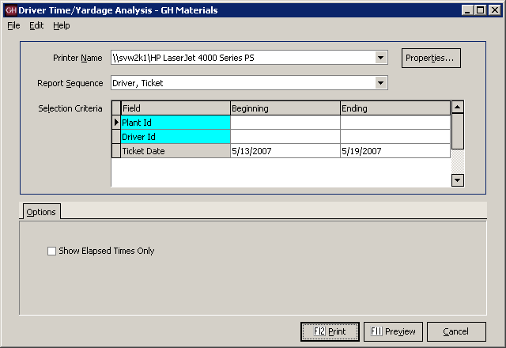  Driver Time/Yardage Analysis Screen
Report Sequence  The report can be run to subtotal by plant or just driver. | 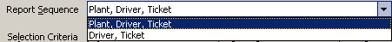  Driver Time/Yardage Analysis – Report Sequence Dropdown List
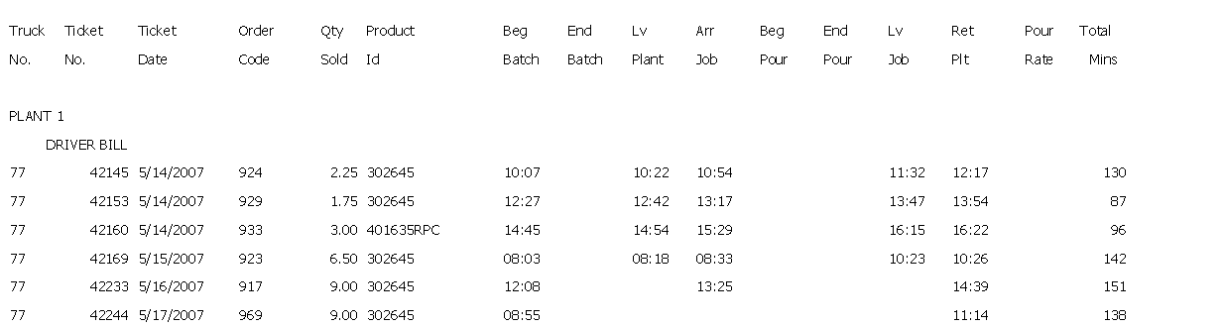
Driver Time/Yardage Analysis – Actual Time mode
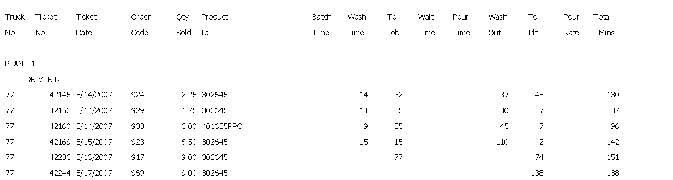
Driver Time/Yardage Analysis – Elapsed mode

Order Time/Yardage Analysis  This report is designed to review the status times of each ticket within an order. It is intended to show an order’s delivery history and productivity.  There are two reporting modes available – actual time and elapsed time.  The first report is a sample of actual time and is the default setting for this report. It shows the time that each load went through each delivery stage. Where no time is available, it leaves a blank.  The second report shows the elapsed time in each stage. | 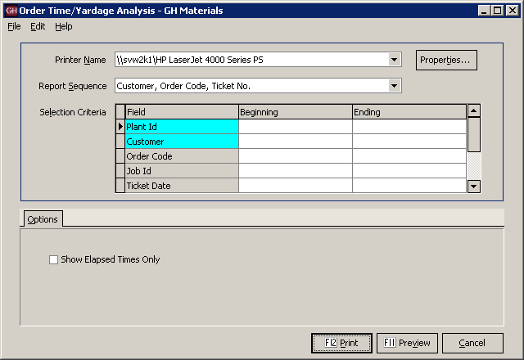  Order Time/Yardage Analysis Screen
Report Sequence  The report can be run to subtotal by each customer’s order or job information in various ways. | 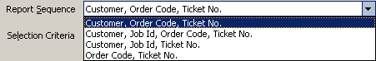  Order Time/Yardage Analysis – Report Sequence Dropdown List
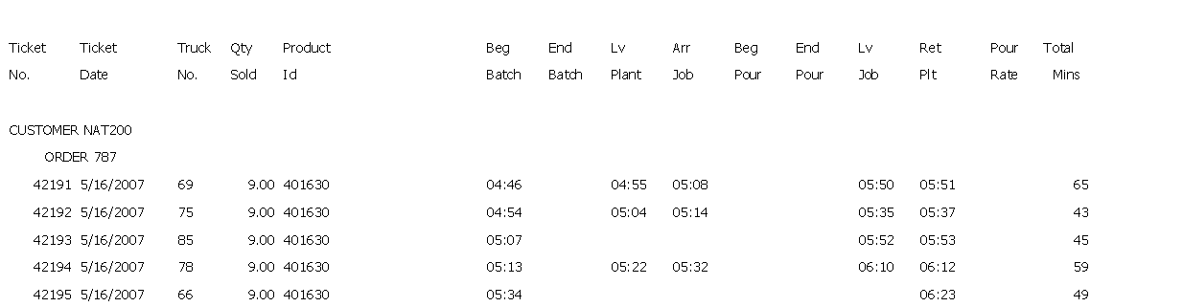
Order Time/Yardage Analysis – Actual Time mode
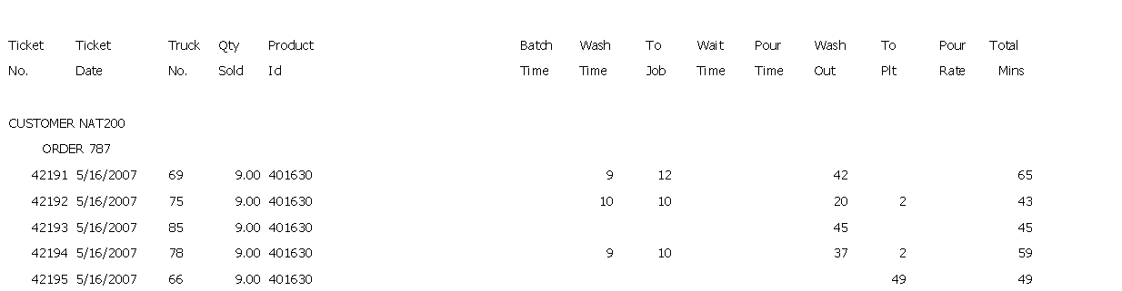
Order Time/Yardage Analysis – Elapsed mode

Plant Time/Yardage Analysis  This report is designed to review the status times of each ticket generated at each plant. It is intended to show the plant’s delivery history and productivity.  There are two reporting modes available – actual time and elapsed time.  The first report is a sample of actual time and is the default setting for this report. It shows the time that each load went through each delivery stage. Where no time is available, it leaves a blank.  The second report shows the elapsed time in each stage. | 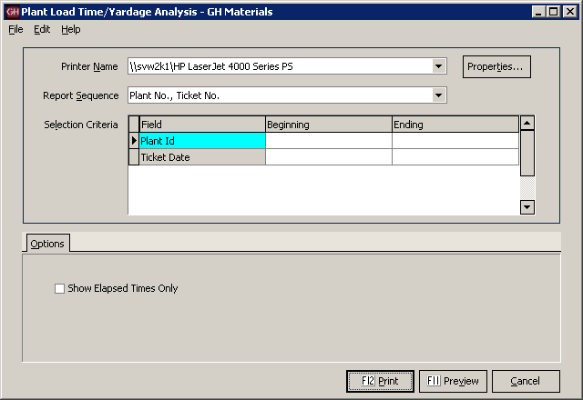  Plant Time/Yardage Analysis Screen
Report Sequence  The report can be run to subtotal each plant, or simply list tickets. | 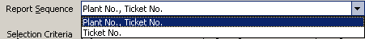  Plant Time/Yardage Analysis Report – Report Sequence Dropdown List
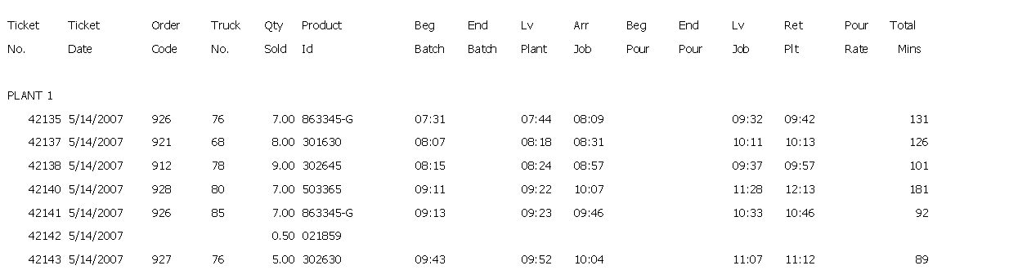
Plant Time/Yardage Analysis – Actual Time mode
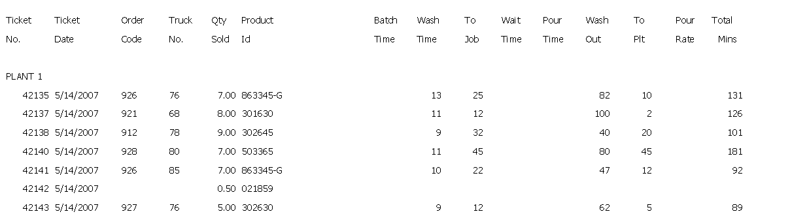
Plant Time/Yardage Analysis – Elapsed mode

Blank Time Fields Report  This report is a diagnostics report designed to show tickets that are missing time values in any delivery phase selected by the user.  All time fields are listed in two columns on the left side of the Options tab. Any tickets containing a blank in any of the checked fields will appear on the report.  The column to the right is used to determine the scope of the report. A dispatcher may only care about current delivery tickets, while a manager may want to see all tickets, regardless of their status. | 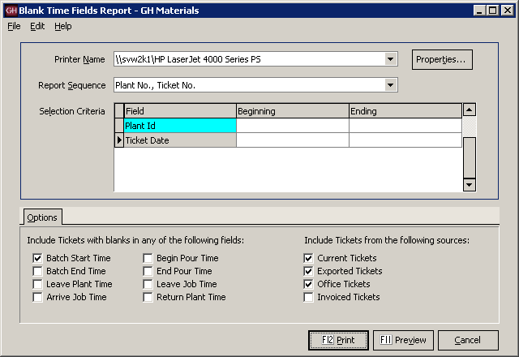  Blank Time Fields Report Screen
Report Sequence  The report can be run to subtotal each plant, or simply list tickets. | Blank Time Fields Report – Report Sequence Dropdown List
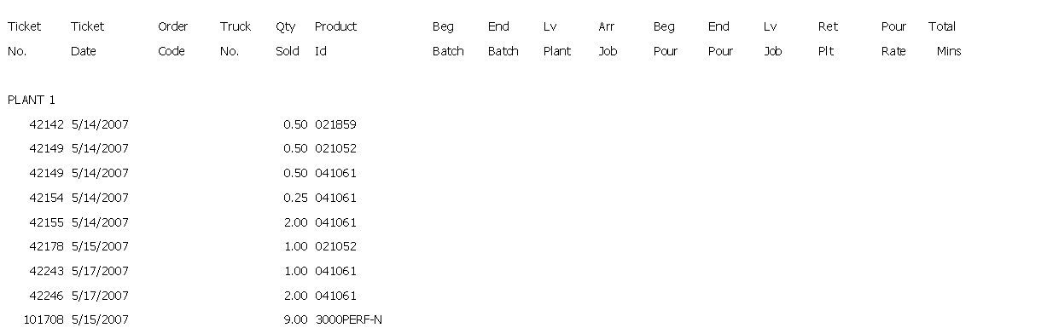
Blank Time Fields Report

Late Times Report  This report is designed to report tickets which may be subject to late charges based on the company’s time allowances.  On the left side of the Options tab, the user selects how the time is calculated, since some operations use batching time, while others don’t start the clock until the truck leaves the plant.  Two additional options allow the user to see the on-time loads (thus giving a complete list of tickets), while another shows tickets that may not have values and thus are not able to be calculated.  On the right side, the base (per load) time, as well as the per yard times are entered. The user may also enter a tolerance for late jobs. For example, the user may only wish to see loads that are later than 15 minutes.  Note that there is also a Ticket Sources tab, allowing users to select which tickets should be included o the report. | 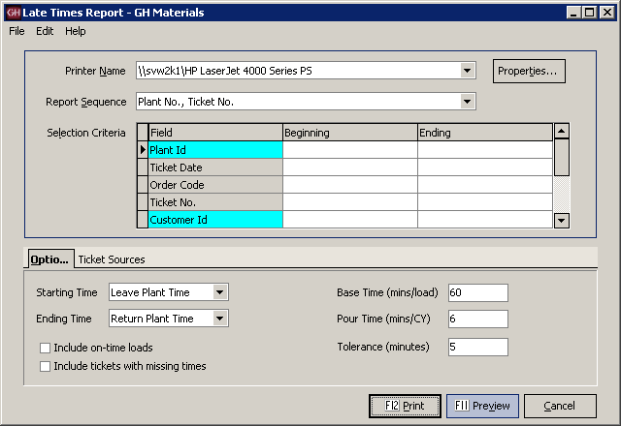  Late Times Report Screen
Report Sequence  The report can be run multiple ways, allowing analysis by plant, job or customer. | 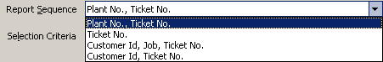  Late Times Report – Report Sequence Dropdown List
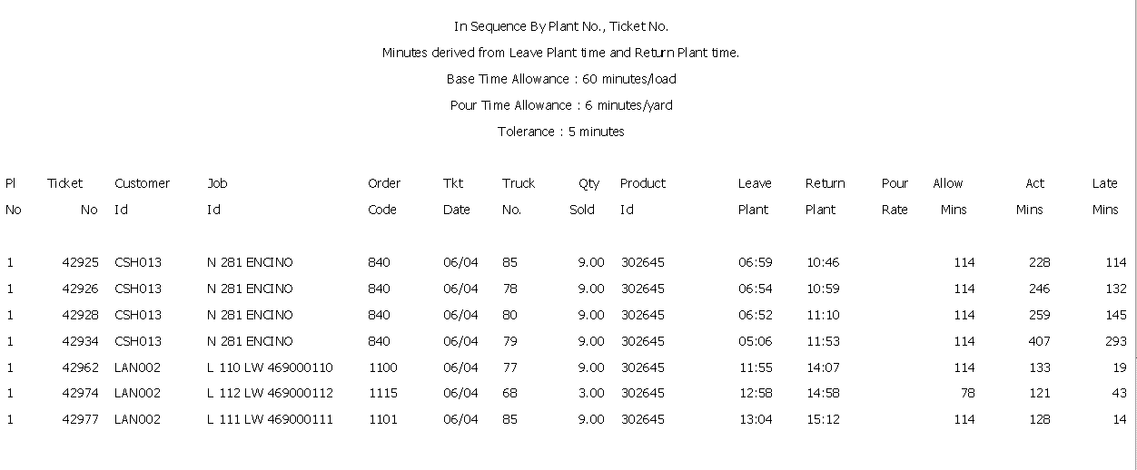
Late Times Report

Ticket Time Analysis  This report is designed to assist in in-depth investigations of time performances. The report uses both individual and cumulative data for each load, allowing the user to make accurate interpretations even when missing some individual data.  The report can be run to focus on large or small scale trends, identifying overall delays, or focused to individual time status readings.  Using current and historical data, this report can offer valuable insight into operations and on-time performance. | 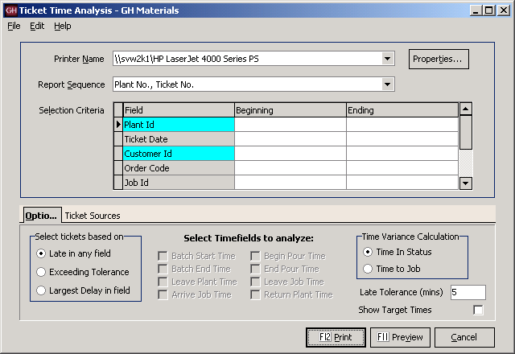  Ticket Time Analysis Screen
Report Sequence  Running this report by Plant and Ticket gives a plant manager a good overview of the plant’s performance, while running by Order is handy for customer service and review. | 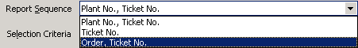  Ticket Time Analysis – Report Sequence Dropdown List
Options Tab  The options selected on this tab offer a great deal of control in generating reports. It is vital to understand how each option works to avoid confusion when reading and interpreting the report. | Ticket Time Analysis – Options Tab
Selecting tickets  This selection allows the user to determine which tickets appear on the report. With ALL selections, the result is still subject to the Late Tolerance value (for the examples below, a 5 minute late tolerance is assumed, however the user may change the value at any time).  Late in any field will include any ticket which was late in any job status (batch time, leave plant, etc.)  Exceeding Tolerance allows the user to select which tickets get flagged based on the field that experienced the delay. Any ticket delayed by more than the Late Tolerance in a selected field is shown.  Largest Delay in Field shows all tickets that exceeded the Late Tolerance and where the longest delay was in the selected field(s). | Ticket Time Analysis – Ticket Selection
Selecting Time fields to analyze  Time field selections works in conjunction with the Exceeding Tolerance and Largest Delay in Field options.  While the report will show all time fields, the selected time fields determine which tickets appear on the report.  At least one time field must be selected for comparison purposes. | 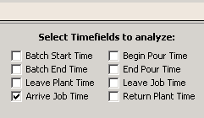  Ticket Time Analysis – Time field Selection
Time Variance Calculation  Next to each field on the report is a number in parenthesis, with a positive number reflecting a status ahead of schedule and a negative number representing delays (eg: +10 means 10 minutes early, -10 means 10 minutes late).  The Time Variance selection determines how this number is calculated.  Time To Job calculates the variance time based on the actual time in a status compared against what was the target time. In this model, delays affect all subsequent status times. For example, if a truck arrives 10 minutes late on the job, the impact of those 10 minutes will show on all remaining times.  Time In Status calculates the variance of each time status by comparing the actual elapsed time within a time status against what as projected. Using this model, a truck that arrived 10 minutes late will show -10, however if it took the expected elapsed time to pour, that time field would show 0.  Note: The option to show target times is disabled when this option is chosen, as the time target time is less important that the actual projected elapsed time. | 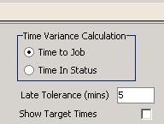  Ticket Time Analysis – Time Variance Calculation

Late Tolerance
The Late Tolerance determines how strictly the report should define “late”. This allows the user to determine how much oversight is needed. For example, a report with 30 minutes tolerance is only going to show loads that were delayed a half-hour or more – a significant problem. A report with only a 5 minute tolerance (the default) will show those same 30 minute late orders, as well as other orders that were late by more than 5 minutes.

Show Target Times
When the Time In Status variance is selected, the user can opt to display the target times immediately under the actual times on the report.
Note: The addition of Target times as well as a blank separator line will cause the resulting report to be approximately three times as long.
Showing target times is not an option with the Time To Job setting, as the target time is not used in calculating the variance.

Ticket Sources Tab  This selection allows the user to determine where to draw the tickets information. By default it selects unbilled tickets, expecting to run on current data only. | 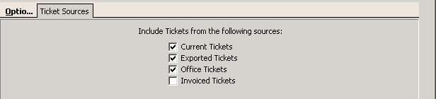  Ticket Time Analysis – Ticket Sources
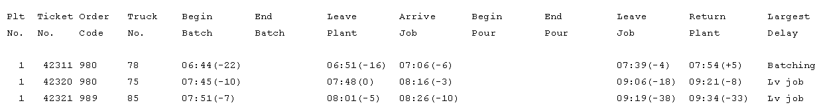
Ticket Time Analysis Report
In this example, three loads were shipped. The first departed 22 minutes late, but made up some time on the way to the job (only arriving 6 minutes late), poured and washed out slightly ahead of schedule, leaving the job only 4 minutes late. It made up the time on the way to the plant, arriving 5 minutes ahead of schedule. In the right-most column, it identified the largest delay as being in batching.
The second load was batched 10 minutes late, and while 7 minutes were made up in transit (arriving only 3 minutes late), delays on the job resulted in the truck leaving 18 minutes late. The driver was able to make up 10 minutes of that in transit, returning only 8 minutes late. Even though the system did not have begin and end pour values, the system identified the problem as being late in leaving the job.
The third load encountered similar on-job problems. It was batched 7 minutes late, lost a few minutes in transit, arriving 10 minutes late. However an additional 28 minutes were lost before leaving the job, resulting in being 38 minutes behind schedule before returning to the plant.

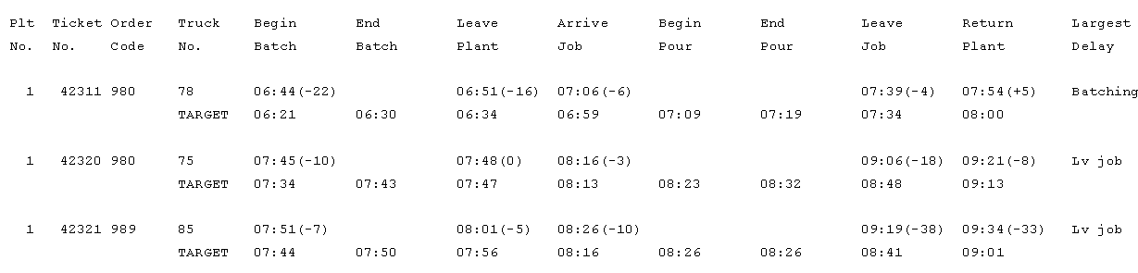
Ticket Time Analysis – with Target Times
This example is the same data as the previous report, except with target times displayed. In cases where data is missing (in this example, the begin and end pour times), seeing the times projected by the system might offer some insight. For example, in all three cases, 10 minutes were allocated between the time the truck arrived on the job and the pour began. Was this reasonable?
In the third job, the begin and end pour were projected to end at the same time, this is likely the source of the delay in the third load. While Keystone flagged this truck as 33 minutes lately, clearly the issue was in how the dispatcher estimated the job.
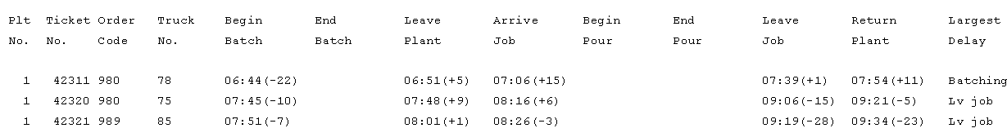
Ticket Time Analysis – Time To Job
This sample is the same data as before, except displayed with the Time To Job method in calculating the variance. Because the variances are calculated within each time status, the results appear dramatically different.

Note: The variance next to begin batch is the same in both reports – this indicates how many minutes early or late that the job was batched from its projected time.

As noted earlier, the first load was batched 22 minutes late, arriving on the job only 6 minutes late. Using the Time To Job method, the report indicates that the first load saved 5 minutes leaving the plant and 15 more minutes in arriving at the job. Another minute was saved during the pour, and 11 more in transit back to the plant.\

The second load shows delays in batching, on-job and returning, but time savings in leaving the plant and arriving at the job.

The third load shows small delays in batching and arriving on the job, with significant delays before leaving and returning to the plant.

Order Audit Trail  This report is designed to provide an audit trail of all order changes. The report is designed to help troubleshoot problems with orders, diagnose “difficult” customers and even assist in loss prevention.  On the Options tab, there is a checkbox of the types of changes which should appear on the report. For the sample below, all changes were requested.  It is common to run the report based on what is being investigated. Changing a unit price is not important in determining why there was a problem with deliveries, but is key as part of loss prevention. | 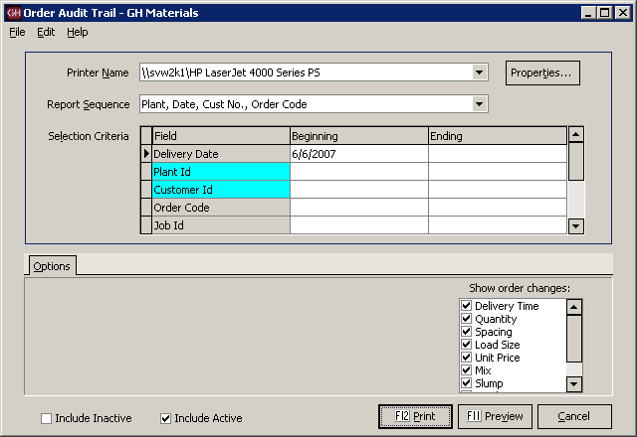  Order Audit Trail Screen
Report Sequence  Running this report by order code is an excellent way to review what may have led to problems or confusion on a given order. . | 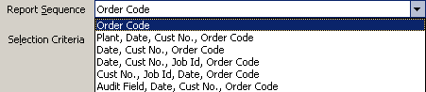  Order Audit Trail – Report Sequence Dropdown List
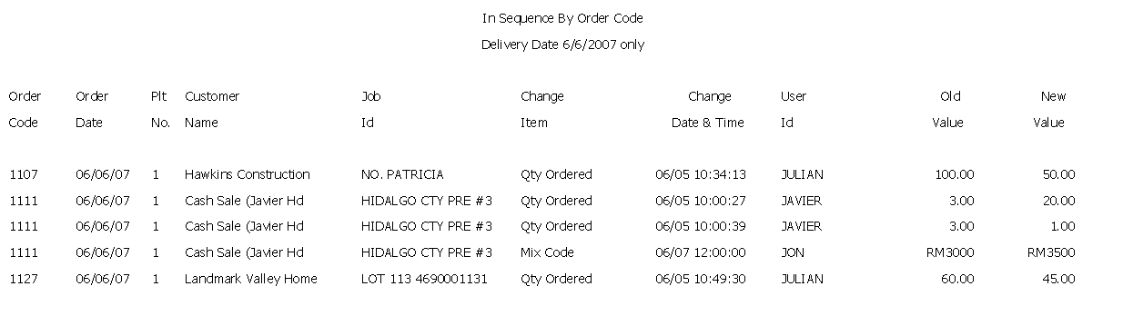
Order Audit Trail Report

Menu Navigation – Utilities
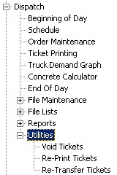 | Menu Overview
  Void Tickets | Voids a delivery ticket, restoring correct quantities and schedules.
  Re-Print Tickets | Generates additional paper copies of tickets without attempting to re-batch the ticket(s).
  Re-Transfer Tickets | Creates another ticket transfer file to transmit to the office.

Void Ticket
There are numerous reasons to void a ticket, such as accidental shipment of an incorrect order, batch control malfunction, etc.  Void Ticket is used to reverse some problems.  By entering the customer, ticket and reason for the void, the delivery ticket is voided (never deleted – it will pass to the billing system as a void ticket).  This will restore the quantity delivered fields, projected loads and schedule screen to the correct values. | 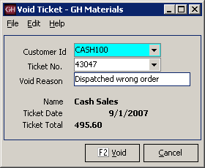  Void Ticket

Re-Print Ticket
Sometimes additional copies of delivery tickets are needed without shipping additional loads.  This could be due to a lost/destroyed ticket or requirements for additional copies due to regulatory or contractual requirements.  Re-Print Ticket fills this need. After selecting the plant, a screen appears allowing the dispatch to select which ticket(s) need to be re-printed.  Note: This function allows multiple tickets to be re-printed. In the sample to the right, a single ticket will be re-printed.  It is also possible to re-print ALL a customer’s delivery tickets by date, or job.  Warning: NEVER simply press F12. This will cause Re-Print tickets to regenerate ALL delivery tickets since the last time End-Of-Day was run. | 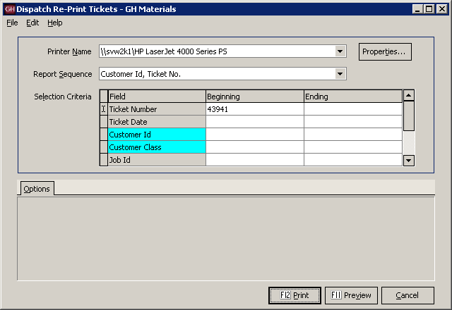  Re-Print Ticket

Re-transfer Dispatch Tickets
(Stand-alone systems only)

This option is only available on stand-alone dispatch systems. It allows the dispatch site to create another export file of tickets for the date(s) selected based on the dates selected by the user. | 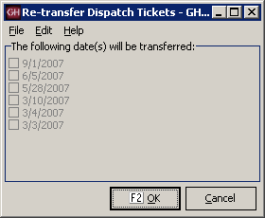  Re-Transfer Dispatch Tickets Screen

Appendix A - Delivery Zones

Zone Methods
There are three commonly used methods for identifying delivery zones, one of which is likely employed at your plant. While changing Dispatch software is an already an upheaval to your organization, now may also be the ideal time to review other business processes and procedures with an eye towards the benefits such changes can bring.
The following review of delivery zone methodology is offered to show the different methodologies commonly employed and the advantages and disadvantages of each. Keystone Dispatch supports each method.

Time-Based times
This is the most commonly used method, as it is easy to set up and simple to use.
The zones are established as the minutes it takes to get to the delivery location. Identifying the delivery location is unimportant, so long as the Dispatcher knows how long it takes to get there.
When keying in an order, the user simply types in the value (or code) for the time it takes to get to the job based on his experience on jobs in that vicinity.
Advantages  - Fastest to set up (15-20 database entries)  - Delivery time doesn’t vary by plant | Disadvantages  - Requires dispatcher to know the area  - No delivery area reporting capabilities.

Delivery-based zones
This method is less commonly used because it requires additional setup. It is simple to use once in place.
The zones are established as the location where the material is being shipped. Typically the name of the town or neighborhood is used. This requires less knowledge of the delivery times, often allow non-dispatch personnel to take orders with a minimal amount of training.
When keying in an order, the user simply types in the code for the delivery neighborhood. The time required to reach that neighborhood is stored in the database. Multiple plants can use the same codes for each neighborhood, as different travel times can be entered for each plant.
Advantages  - Delivery area identified for later reporting.  - Non-dispatch personnel can take orders.  - An order shipped from more than one plant won’t need to be edited to reflect different travel times. | Disadvantages  - Longer setup (potentially hundreds of entries)  - Must enter all delivery locations for ALL plants.  - User must learn or lookup codes for areas.

Map-based zones
This method is similar to the delivery-based model however uses map coordinates to identify locations rather than coding each area.
The zones are based on a common map. Some maps are based on a large grid, while others take the local geography into account to build custom maps based on delivery time experience.
When keying in an order, the user enters the code for the delivery area. The time required to reach that area is stored in the database. Multiple plants can use the same codes, as different travel times can be entered for each plant.
Advantages  - Delivery area identified for later reporting.  - Non-dispatch personnel can take orders.  - An order shipped from more than one plant won’t need to be edited to reflect different travel times. | Disadvantages  - Longer setup (fewer entries than the delivery-based method, but more than time-based)  - Must enter all delivery locations for ALL plants.  - User must learn or lookup codes for areas.

